📣 Define my brand voice and visual style

My non-monolithic brand voice

The register dial — how the spine flexes by surface
Same person, different room. This is the part a design agent most needs spelled out:
Property | Register | Warmth | Length | What shifts
barbhs.com / consulting | Authoritative, proof-driven | Medium | Fuller sentences | Leads with business impact; "I" voice; receipts attached
Sensemaking AI (marketing + essays) | Mission-forward, a touch visionary | Medium-high | Punchy | "We/you"; biggest claims live here, still un-hyped
In-product microcopy | The voice of a steady teammate | High | ≤20 words, terse | No exclamation points, no emoji; curious, never punitive
BS Detector Workshop | Accessible, read-aloud | High | Spoken rhythm | Zero jargon out loud; calibrated, not cynical
twin.barbhs.com (Digital Twin) | Conversational, first-person | High | Natural | Most casual; sounds like you talking

Links to style guides:
- Sensemaking-AI’s WARM style guide
- Sensemaking-AI’s CURRICULUM style guide
- Template that describes my voice

Visual Style Specification - Personal brand & cons

Visual Style Specification — Personal Brand & Consulting
Handoff document for design and front-end agents · Version 1.0
barbhs.com and consulting surfaces
Companion to the Voice Specification v1.0

0 · Decisions taken (read first)
Two questions were resolved before this spec was written. The agent should treat both as fixed.

- Shared brand DNA, senior expression. This is not a separate brand from the Sensemaking AI app. It draws from one token foundation and expresses the serious end of it. Family resemblance across properties is intentional.
- Stay on Minimal Mistakes (Jekyll / GitHub Pages). Express the brand as an SCSS skin plus framework-agnostic tokens. Do not re-platform. See §8.

1 · The idea the visuals carry
Calm, editorial, senior, human. The surface should feel like room to think. A cognitive scientist who builds working systems, not a consumer app and not an academic blog. Generous whitespace, warm neutrals, one confident brand color, restrained accent use. Flat surfaces, no gradients or glow, which matches the calm register of the voice.

2 · Relationship to the Sensemaking AI app
Carries over | Reserved for the app only
Deep teal as primary brand | Lavender #7B6CF6
Charcoal / slate ink | Mist blue #ABC7FF
Ivory + warm sand foundation | Sage #7DB68A (one possible exception: a quiet success tint)
Serif-display + sans-body pairing | Full multi-accent playfulness
Soft radii, hairline borders, airy spacing | —
Line-art node/graph illustration motif | —

The personal brand uses fewer colors and more restraint than the app. A consumer-learning audience can carry bright accents; a consulting buyer reads them as less senior.

3 · Color tokens
Values are carried from the app design system. Confirm exact hex against a canonical token source if one exists; these were read from the app mockup.

Token | Hex | Role | Usage notes
--c-ivory | #FAF7F2 | Page background | Default canvas everywhere
--c-sand | #F4E9D6 | Secondary surface | Cards, callouts, footer, pull-quotes
--c-charcoal | #1F2937 | Primary text / ink | Body copy, headings
--c-slate | #6B7280 | Secondary text | Captions, metadata, muted labels
--c-teal-deep | #0E5F6B | Primary brand | Links, primary buttons, heading accents, the mark
--c-teal | #1FA39A | Brand accent | Hover states, focus rings, small highlights, borders
--c-coral | #FF7A66 | Reserved accent | Sparing. One CTA or one highlight per view. Not for text.

Usage rules:
- One primary brand color does the work. Deep teal is the anchor. Teal is its hover and accent partner.
- Coral is a guest, not a resident. It appears at most once per view, on a non-text element.
- Backgrounds stay warm and quiet. Charcoal and slate carry all text.
- No gradients. Solid fills only.

4 · Typography

Pairing (recommended)
- Display and headings: Source Serif 4
- Body and UI: Source Sans 3

Rationale: the two are designed to pair, carry a broad weight range, are open-source and free on Google Fonts, and self-host cleanly. Low maintenance for a solo developer. The serif gives editorial credibility that fits a cognitive scientist; the sans keeps the surface modern and legible for consulting buyers.

Alternative with more personality (display only): Fraunces for headings, Inter for body. Choose this if the brand should feel more distinctive. Fraunces can skew fashion-editorial, so keep weights moderate.

If the app already commits to a specific serif, mirror it for family coherence and ignore the above.

Type scale (modular, ~1.25)
Element | Size | Weight | Notes
Body | 18px / 1.6 | 400 | Reading measure ~66–75 characters
Small / caption | 15px | 400 | slate
H3 | 22px | 500
H2 | 28px | 500
H1 | 40px | 500
Hero display | 56–64px | 500–600 | Landing hero only

- Sentence case on all headings and labels. This matches the voice spec.
- Heading weight stays at 500, occasionally 600 for a hero. Avoid 700; it reads heavy against the warm palette.
- Body line-height of 1.6–1.7 reinforces the room-to-think feel.

5 · Layout and space
- Prose max-width ~680–760px for a comfortable reading measure.
- Generous vertical rhythm: 1rem / 1.5rem / 2rem steps. Whitespace is a brand signal, not empty space.
- Corner radius: 12px on cards, 8px on controls. Carried from the app.
- Borders: 0.5–1px hairlines in slate at low opacity. Prefer hairlines over shadows.
- Shadows: none, or one very soft shadow on a raised card. No SaaS-style elevation stacks.
- Flat surfaces throughout.

6 · Illustration and imagery
- Signature motif: light line-art network maps. Nodes, dotted connecting paths, a few small card glyphs, the style already present in the app concept board. Render in monochrome deep teal on ivory, sparse. It literalizes "making meaning from messy data," scattered points resolving into connected structure. Use it for hero accents, section dividers, and the mark.
- Photography: if used, warm and natural. A real headshot on the about and home surfaces builds consulting credibility. Avoid stock imagery.
- Avoid: glowing-brain or robot AI clichés, neon or sci-fi treatments, gradient meshes, 3D blobs, heavy drop shadows.

7 · Do / Don't
Do | Don't
Lean on whitespace and one confident brand color | Fill space with accents or decoration
Use the line-art node motif as the visual signature | Use generic AI stock imagery
Keep surfaces flat with hairline borders | Add gradients, glow, or shadow stacks
Sentence case everywhere | Title Case or ALL CAPS
Reserve coral for a single non-text moment | Spread coral across text and UI
Keep the brighter app accents off this surface | Import lavender, mist blue, sage here

8 · Minimal Mistakes mapping
Express the brand as a custom skin plus framework-agnostic tokens. This keeps a future migration cheap.

Approach
- Define the palette once as CSS custom properties in a tokens partial (for example _sass/_tokens.scss exposing :root { --c-teal-deep: #0E5F6B; … }). Custom utility classes reference the variables, never raw hex. A later move off Minimal Mistakes then carries the tokens unchanged.
- Create a brand skin file (_sass/minimal-mistakes/skins/_brand.scss) and set minimal_mistakes_skin: "brand" in _config.yml.
- Set the theme SCSS variables to the brand values.
- Load fonts in _includes/head/custom.html via a Google Fonts link, or self-host under /assets/fonts for resilience.

Key SCSS variables to set
$background-color: #FAF7F2; // ivory
$text-color: #1F2937; // charcoal
$muted-text-color: #6B7280; // slate
$primary-color: #0E5F6B; // deep teal
$link-color: #0E5F6B;
$link-color-hover: #1FA39A; // teal
$link-color-visited: #0E5F6B;
$masthead-link-color:#1F2937;
$border-color: rgba(107,114,128,0.25); // slate hairline
$footer-background-color: #F4E9D6; // warm sand
$serif: "Source Serif 4", Georgia, serif;
$sans-serif: "Source Sans 3", -apple-system, BlinkMacSystemFont, sans-serif;
$global-font-family: $sans-serif;
$header-font-family: $serif;

Layout note
The default Minimal Mistakes masthead and author sidebar read a little academic for a consulting home. A custom splash or home layout with the line-art hero is a sensible later step. It is optional and not required for this brand to land.

9 · Accessibility (contrast)
Approximate ratios on the ivory background. Confirm with a checker before shipping.

Pair | Ratio | Verdict
Charcoal #1F2937 on ivory | ~14:1 | Passes AA and AAA
Deep teal #0E5F6B on ivory | ~6.5:1 | Passes AA for text and links
Slate #6B7280 on ivory | ~4.6:1 | Passes AA for normal text; fine for secondary
Teal #1FA39A on ivory | ~2.3:1 | Non-text only: borders, hovers, focus rings
Coral #FF7A66 on ivory | ~2:1 | Non-text only, or darken for any text use

Rule: teal and coral are decoration and state, not reading text. Charcoal, slate, and deep teal carry all copy.

10 · Open items for handoff
- Confirm exact hex values against a canonical token source if one exists. These were read from the app mockup.
- Final font decision: the Source pairing (recommended) versus the Fraunces + Inter alternative.
- Decide whether the Minimal Mistakes author sidebar stays on the home and about surfaces or is replaced by a custom splash layout.

End of spec. Pair with the Voice Specification v1.0 for the complete brief.

Ref: https://claude.ai/chat/f207b385-9620-4e85-8944-6e45296c2541

Voice Specification - Personal brand & consulting

Voice Specification — Personal Brand & Consulting
Handoff document for writing and design agents · Version 1.0 ·
Barbara Hidalgo-Sotelo Scope: barbhs.com, consulting proposals, LinkedIn, application materials, speaking blurbs, bios ·
Companion to the Visual Style Specification v1.0

0 · How to use this document (agent instructions)
- This spec governs personal-brand and consulting prose only. It does not govern Sensemaking AI in-product microcopy or the BS Detector Workshop script. Those are separate registers with their own rules.
- Work in two passes. Draft against §2–§6 and the anchor in §7. Then run an audit pass against §6 and the checklist in §9. The audit is mandatory, not optional; it catches what generation lets through.
- When a sentence could go several directions, match the cadence of the anchor in §7 and obey the prohibitions in §6.
- The single governing test, from §9: if a sentence could appear in anyone's article on this topic, rewrite it as something only she could have written.

1 · Whose voice this is
A cognitive scientist (PhD, MIT) working as an independent applied-AI and data-science consultant. Not attached to one enterprise. She advises, architects, and translates; she is not a pure individual contributor. Business impact comes first, technical implementation second.

Headline (verbatim, do not paraphrase):

Exploring messy data, intelligent systems, and what it means to make meaning — through the lens of a cognitive scientist who builds things people use.

Tagline: Making meaning from messy data.

Identity vs. job title: "Knowledge Scientist" is the story she tells in public and in thought leadership. "Applied AI Architect" is the door she walks through on applications. Use the architect framing on market-facing materials; the Knowledge Scientist framing on brand and speaking surfaces.

2 · The voice in one paragraph
Plain, direct prose with a real point of view. She earns authority by analyzing the problem well, not by announcing her credentials. Claims arrive with evidence attached: a project, a number, a workflow she has actually sat inside. She treats the reader as a capable peer. The cognitive-science training shows up in how she frames a problem — what the real question is, what representation makes it legible, what would change her confidence — and almost never as theory on display. No hype, no rhetorical throat-clearing, no slogan repeated until it wears out.

3 · The spine — six traits
These hold across every personal-brand and consulting surface.

Trait | What it sounds like (her words) | Lean toward
Plainspoken precision | "the last mile" · "things people actually use" | Concrete nouns and exact meaning over rhetorical moves
Earned confidence | "live and running, not sitting in notebooks" | State the claim, then show the receipt
Adult & direct | analyzes tradeoffs as a peer would | Respect the reader's intelligence; never explain importance, demonstrate it
Cognitive-science spine, worn lightly | "what it means to make meaning" | Frame around the real question, representation, and what updates confidence
Concrete over abstract | "4M+ bills a year at 92% accuracy" | A real example beats any analogy
Capability over convenience | builds judgment, not just speed | Center the person's agency and the operational reality

4 · Where the voice sits (for calibration)
When a line could read warmer or cooler, default to the position below:

- Plainspoken, strongly. Almost never ornate.
- Warm but adult. Friendly to a peer, not gushing, not clinical.
- Confident, strongly. No hedging, no pre-emptive qualifiers.
- Concrete, strongly, with intellectual grounding underneath rather than on the surface.
- Calm. Zero hype register.
- Teaching, not performing. Generous with insight; never showing off.

None of these sit at the extreme. The restraint is the brand.

5 · DO
- Lead with the problem or the outcome. Let the reader feel the expertise before they see the label.
- Attach evidence to claims: named projects, real numbers, a workflow she has operated inside.
- Use mechanism words when they carry weight: representation, prior, constraint, tradeoff, readiness, evaluation, the last mile.
- Keep a real point of view. A sentence anyone could have written is a defect.
- Pass the read-aloud test. If it trips the tongue or sounds clever-but-hollow, rewrite it.

6 · DON'T — the anti-slop rules (authoritative)
Paste this block into any generation prompt for these surfaces.

WRITING CONSTRAINTS — read before drafting:

Default to concrete specifics over rhetorical moves. Whenever tempted to reach
for a contrast, an analogy, or an emphasis cue, reach for a real detail,
example, or mechanism instead.

- No "it's not X, it's Y" constructions or variants ("never X, but Y";
"isn't about X, it's about Y"; "the X isn't the point, the Y is"). If a
contrast is truly needed, state the real thing directly, at most once.

- Don't open by announcing background or credentials ("As a…", "Coming from…",
"With my background in…"). Let expertise show through the analysis.

- No glib equivalence analogies ("it's exactly like…", "we've seen this movie
before", "think of it as…") unless the comparison is precise and
load-bearing. One real example beats one borrowed analogy.

- No emphasis cues that announce importance instead of earning it ("This is
the part I'd underline", "The key point is", "Notice that…", "Make no
mistake", "Here's the thing"). Cut them; let the sentence carry its weight.

- No three-item adjective or clause stacks for rhythm ("fast, confident, and
wrong"). Pick the one that's true. (Factual enumerations of real stages or
items are fine — the ban is on stacking for cadence.)

- Don't milk a slogan. If a line sounds quotable, use it once and move on.

- Go easy on em-dashes, hedging filler ("it's worth noting", "to some
extent"), and empty intensifiers ("truly", "really", "incredibly").

Voice: plain, direct prose with a real point of view. If a sentence could
appear in anyone's article on this topic, it's too generic — rewrite it as
something only she could have written.

7 · Voice anchor — match this cadence

7a · Raw anchor (her own writing, for personality and rhythm)
I co-founded a home health agency. I've sat in state auditor meetings, dealt with payer requirements, co-developed an EMR system from scratch, and navigated HIPAA compliance operationally, not theoretically. When I later built an ML classifier for medical bill adjudication that processed 4M+ bills annually and hit 92% accuracy, I didn't just optimize a metric. I designed the classification scheme around how claims adjusters actually think about their work, because I'd been on the other side of that workflow. That breadth isn't diffusion. Data scientists understand models but not the operational reality of the people who'll use them. Domain experts understand workflows but can't architect systems. I've been on all three sides, and I solve the integration problem between them.

Note for the agent: this sample predates the anti-slop rules and contains two patterns §6 now flags — a near "not X, I did Y" move and an em-dash run. Match its directness, specificity, and point of view. Obey §6 where they conflict. Use §7b as the clean target.

7b · Refreshed anchor (her voice under the current rules — the target)
I take projects from fuzzy requirements through architecture, implementation, and deployment, then present the results to a C-suite or debug the pipeline myself, depending on what the day needs. I co-founded a home health agency, sat in state auditor meetings, and navigated HIPAA operationally. When I built an ML classifier for medical bill adjudication, it processed over four million bills a year at 92% accuracy. The accuracy came from designing the classification scheme around how claims adjusters actually reason about a claim, which I knew because I had done the work. That is the pattern across my projects: a system earns trust by fitting how the people using it already think.

8 · Lexicon
Prefer | Avoid
Concrete nouns; named projects; real numbers (4M bills, 92%, 1,000-participant study) | revolutionary, game-changing, unlock, supercharge, 10x
the last mile · readiness · representation · prior · tradeoff · constraint | leverage (as a verb), seamless, robust, cutting-edge
build · ship · design · advise · translate · architect | "in today's fast-paced world", "at the end of the day"
Direct claims with evidence | "here's the thing", "notice that", "make no mistake", "the key point is"
Earned single contrasts, stated once | "it's not X, it's Y" and all its variants
"As a [role]…" replaced by analysis that shows the expertise | "As a cognitive scientist…", "With my background in…"

9 · Audit pass — self-edit checklist
Run every draft against this before it ships.

- Search for not … it's / isn't … it's / never … but. Is each one earned, and is there more than one? Cut the rest.
- Does the opening announce who she is instead of showing how she thinks? Rewrite the opening.
- Any it's exactly like / same as / think of it as? Replace with a real example.
- Any the key point / notice that / make no mistake / here's the thing? Delete.
- Any three-adjective or three-clause stacks for rhythm? Cut to the one that's true. (Real enumerations are fine.)
- Any quotable line restated or stretched into a paragraph? Use it once, move on.
- Em-dash count: is each one doing real work, or just rhythm?
- The generic test: could any competent writer on this topic have written this sentence? If yes, make it specifically hers.

10 · Before / after
Concrete transforms an agent can pattern-match against.

Pattern | Slop | Her voice
not-X-it's-Y | "It's not about the model, it's about the outcome." | "I optimize for whether a claims adjuster trusts the output enough to act on it. The model is how I get there."
Credential open | "As a cognitive scientist, I bring a different lens to AI." | "I built the bill-adjudication classifier around how adjusters reason about a claim. That is where the 92% came from."
Glib analogy | "Think of RAG as a librarian fetching the right book." | "A RAG system decides what prior knowledge to bring to a query before it retrieves anything. Get the chunking wrong and no embedding model saves you."
Emphasis cue | "Here's the key point: evaluation matters." | "Evaluation ships with the system, not after it."
Triad for rhythm | "fast, confident, and wrong" | "confidently wrong"
Milked slogan | "Making meaning from messy data" repeated three times across a page | Use it once, as a tagline, then never again in the same piece.

End of spec. Pair with the visual-style document (forthcoming) for a complete brief.

Ref: https://claude.ai/chat/f207b385-9620-4e85-8944-6e45296c2541

Anti-Slop writing prompt

Anti-Slop Writing Kit
A reusable resource for getting LLM writing help without the tell-tale AI rhetoric.

1. The prompt addendum (paste into any writing-help prompt)
WRITING CONSTRAINTS — read before drafting:

Default to concrete specifics over rhetorical moves. Whenever you're tempted to
reach for a contrast, an analogy, or an emphasis cue, reach for a real detail,
example, or mechanism instead.

- No "it's not X, it's Y" constructions or variants ("never X, but Y"; "isn't
about X, it's about Y"; "the X isn't the point, the Y is"). If a contrast is
truly needed, state the real thing directly, and at most once in the piece.

- Don't open by announcing background or credentials ("As a…", "Coming from…",
"With my background in…"). Let expertise show through how the problem is
analyzed, not through a label.

- No glib equivalence analogies ("it's exactly like…", "we've seen this movie
before", "think of it as…") unless the comparison is precise and load-bearing.
One real example beats one borrowed analogy.

- No emphasis cues that announce importance instead of earning it ("This is the
part I'd underline", "The key point is", "Notice that…", "Make no mistake",
"Here's the thing"). Cut them; let the sentence carry its own weight.

- No three-item adjective or clause stacks for rhythm ("fast, confident, and
wrong"). Pick the one that's true.

- Don't milk a slogan. If a line sounds quotable, use it once and move on.

- Go easy on em-dashes, hedging filler ("it's worth noting", "to some extent"),
and empty intensifiers ("truly", "really", "incredibly").

Voice: plain, direct prose with a real point of view. If a sentence could appear in anyone's article on this topic, it's too generic — rewrite it as something
only I could have written.

2. Stronger than the addendum alone
Add a positive voice anchor. Negative constraints suppress the obvious tells but don't teach your cadence. Paste 200–300 words of your own past writing alongside the constraints: "Match the voice in this sample." Do both for real lift.

Make it persistent. Trim the addendum and put it in your writing style settings so it applies automatically without re-pasting. (In ChatGPT, the equivalent is custom instructions.)

Use two passes. Generation and editing are different jobs. Draft first, then run a second prompt: "Audit this draft against the constraints and flag every violation with a specific fix." The audit pass catches what slips through generation.

3. Self-edit checklist (run your own drafts against this)
- Search for "not … it's" / "isn't … it's" / "never … but" — is each one earned, and is there more than one?
- Does the opening announce who I am instead of showing how I think?
- Any "it's exactly like / same as / think of it as"? Replace with a real example.
- Any "the key point / notice that / make no mistake / here's the thing"? Delete.
- Any three-adjective or three-clause stacks? Cut to one.
- Any quotable line restated or stretched into a paragraph? Use once, move on.
- Em-dash count: is it doing real work or just rhythm?
- The generic test: could any competent writer on this topic have written this sentence? If yes, make it specifically mine.

TO POST SUN: How Machines Read Your Website
As of Friday/Saturday: WORK IN PROGRESS HERE | Thread for creating hero cards

The Three Readers of Your Web Page

Here's the setup. You have a personal site built with Jekyll, hosted for free on GitHub Pages. The content is good. The writing is yours. And yet, when you search your own name, the result is thinner than you'd like — or when you paste a link into LinkedIn, the preview is a gray rectangle and a cropped logo. You go looking for "how to improve my metadata," and within ten minutes you're drowning in acronyms: OG, SEO, JSON-LD, canonical, schema. They all seem to live in the same place — that mysterious <head> tag at the top of every page — so it's natural to assume they all do the same job.

They don't. And the single most clarifying idea in this whole topic is this: your page's <head> is not read by one audience. It's read by three, and each one speaks a different language. Once you can see the three readers, every confusing acronym snaps into a slot, and you stop optimizing the wrong tag for the wrong machine.

This article is the conceptual tour. A companion piece walks through the exact changes to make in your repo. For now, let's just learn how the web actually reads you.

[FIGURE 1 HERE]

The <head> is a room with three readers in it
Think of the <head> of an HTML page as a room where you've pinned up a set of index cards about the page. Three very different visitors walk through that room, and each one only reads the cards written in a vocabulary they understand. They ignore the rest entirely — politely, silently. The web was designed this way on purpose: a client reads the tags it knows and skips the ones it doesn't, so you can write cards for all three audiences in the same room without anyone getting confused.

The three readers are the browser, the search engine, and the social unfurler. They have different jobs, so they care about different cards.

The other side of the glass. This piece is about who reads the cards. If you're curious who writes them, here's [a map of how this very site's <head> is assembled]({{ '/assets/diagrams/head-architecture-v2.svg' | relative_url }}) — every Jekyll include and data file, and the exact tags each one injects. The [companion implementation post]({% post_url 2026-03-18-implementing-structured-metadata-jekyll %}#audit-your-head) embeds it in context.

Reader one: the browser (it has to render you)
The browser is the only reader a human directly experiences, and ironically it cares least about the cards you agonize over. It wants the practical stuff: the character encoding (charset, so your apostrophes don't turn into mojibake), the viewport (so the layout adapts to a phone), the <title> (which becomes the tab label), and a few cosmetic touches like theme-color and the favicon. That's mostly it. The browser is here to paint the page, and these tags tell it how.

If your site renders correctly on a phone and shows the right name in the tab, the browser is satisfied. None of this affects how you're found — it affects how you're displayed once someone has already arrived.

Reader two: the search engine (it has to find, judge, and show you)
This is the reader you actually care about when you say "metadata positioning," and it's worth understanding that it doesn't do one thing — it does three, in sequence. I find it clearest to think of a three-stage pipeline.

Stage one is crawl and index — traffic control. A search crawler fetches your URL and asks two yes/no questions: am I allowed to store this page, and which version of it is the real one? The tags that answer are the robots directive (index or noindex, follow or nofollow) and the canonical link, which points at the official URL when several near-duplicates exist. These don't make you rank. They're the gate. Get them wrong and a page silently never enters the index at all — the worst failure, because it's invisible. You won't see an error; you'll just never appear.

Stage two is understand and rank — meaning. Now the engine asks what is this page about, and how much should I trust it? The honest answer is that this is driven overwhelmingly by your actual content — your headings, your prose, your links, your image alt text — read by some fairly sophisticated language models. Among the metadata, the <title> tag is the one strong signal here. And then there's a special category called structured data, which doesn't rank you but does something subtler and, for some of us, more interesting: it states, in a machine-readable vocabulary, what kind of thing the page is about. A person. An article. A piece of software. We'll come back to this, because it's the layer most personal sites are missing.

Stage three is display — the result on screen. Finally the engine decides how you look in the results list. Your <title> becomes the blue clickable line. Your meta description becomes the gray snippet underneath — though a useful thing to know is that the engine rewrites that snippet roughly more often than not, whenever it thinks a sentence pulled from your page answers the query better. So treat your description as a strong suggestion, not a guarantee. Structured data, if present, can unlock richer result formats here too.

Suggested graphic — the pipeline. Three boxes left to right: Crawl & index → Understand & rank → Display, each annotated with the tags that act at that stage (robots/canonical, then title/structured-data, then title/description). The point of the visual is that different tags act at different stages — a reader should leave understanding that canonical and meta description aren't competing, they're working in different rooms.

Reader three: the social unfurler (it has to preview you)
The third reader shows up whenever someone pastes your link into a feed or a chat — LinkedIn, Slack, iMessage, WhatsApp, Discord, X. Its job is to "unfurl" the bare URL into a rich preview card: a title, a blurb, and a big image. The vocabulary it reads is Open Graph — the family of tags that start with og:. og:title, og:description, og:image, and a few companions are what make your shared link look like a designed object instead of a naked string.

This reader is the reason your LinkedIn previews look the way they do. If the card is ugly, this is the reader to talk to.

The misconception that reorganizes everything
Here's the part worth slowing down for, because almost everyone gets it backwards. Open Graph is a social-sharing protocol, not a search-engine protocol. It was invented by Facebook in 2010 so platforms could render previews. The major search engines, for ranking purposes, essentially ignore it. Which means: perfecting your og: tags will make your shared links beautiful — and will do almost nothing for how you rank.

There is exactly one crossover, and it's worth knowing precisely because it's the exception that proves the rule: a search engine may borrow your og:image as one candidate when it needs to pick a thumbnail for a result. So of all the Open Graph tags, the image is the only one that brushes up against search at all, and even then only for display, never for ranking.

The practical upshot for your Jekyll site: the work that makes your links look great (Open Graph) and the work that makes you findable and legible (titles, canonical/robots, and structured data) are two different projects. Both are worth doing. But conflating them is why people pour effort into og: tags and wonder why their search presence doesn't budge.

Suggested graphic — the myth-buster. A simple two-column "common belief vs. reality" card. Left: "Open Graph tags improve my Google ranking." Right: "Open Graph governs link previews. Search ranking runs on title + content + structured data. The one overlap: og:image can become a thumbnail." Keep it spare — this is the single correction the whole article hinges on.

The deeper idea: metadata is a knowledge graph in disguise
If you have any background in knowledge representation — or you just like when things turn out to be the same thing underneath — this is the satisfying part.

An Open Graph tag isn't a magic keyword. The property="og:title" syntax is RDFa, and og is a namespace prefix pointing at a published vocabulary. Which means an og: tag is literally a triple — a tiny statement of the form (subject) — (predicate) — (object): this page → has the title → "…". It's the same subject-predicate-object grammar you'd write in a graph database, just expressed in HTML instead of Cypher or Turtle.

Structured data (the JSON-LD kind) is the same idea, one level richer. Instead of describing the page, it describes the entities the page is about, using a shared public ontology called Schema.org. A personal homepage isn't really "a page" — it's a page about a person. Structured data lets you say exactly that: there is a Person named Barbara; her job title is this; here is her image; and — crucially — she is the same as this GitHub profile and that LinkedIn profile.

That last move is the one I'd underline. The sameAs property in Schema.org is, functionally, owl:sameAs — the identity statement that lets a reasoner merge two references into one entity. When you list your profiles in sameAs, you are handing the search engine the edges it needs to reconcile your scattered web presence — your site, your code, your writing, your professional profile — into a single, trusted node. You are, in the most literal sense, doing entity reconciliation on yourself.

There's a cognitive-science echo here too, which is why I keep coming back to this topic. A memory isn't retrieved by brute force; it's retrieved through context — the cues and associations that point to it. Metadata is the web's version of that context. The page is the memory; the structured data is the set of associations that let the right query surface it. "Metadata matters" isn't a slogan about tidiness. It's a claim about how retrieval works, in heads and in machines alike.

Suggested graphic — the triple. Three connected nodes: This page → og:title → "…" drawn as a graph edge, sitting next to the equivalent JSON-LD Person → sameAs → GitHub. The visual argument: "these tags you've been treating as form fields are actually graph statements." For your audience specifically, this is the image that earns the article.

Where this goes next
So that's the map. Your <head> serves three readers; the browser renders you, the search engine finds and judges and shows you, and the social unfurler previews you. Open Graph dresses the link; titles, canonical/robots, and structured data make you legible to search.

The companion piece, Implementing Structured Metadata on a Jekyll + GitHub Pages Site, turns this understanding into a checklist: how to audit your own <head>, how to pick and enforce a single canonical home for your site, how to emit clean structured data from a _data file the way you'd manage any other source of truth, and how to verify the result against the tools each reader actually uses. The concepts are the hard part, and now you have vocabulary and an understanding of the non-human consumers of your webpage. The rest is plumbing — satisfying, legible plumbing.

HERO OR GRAPHIC

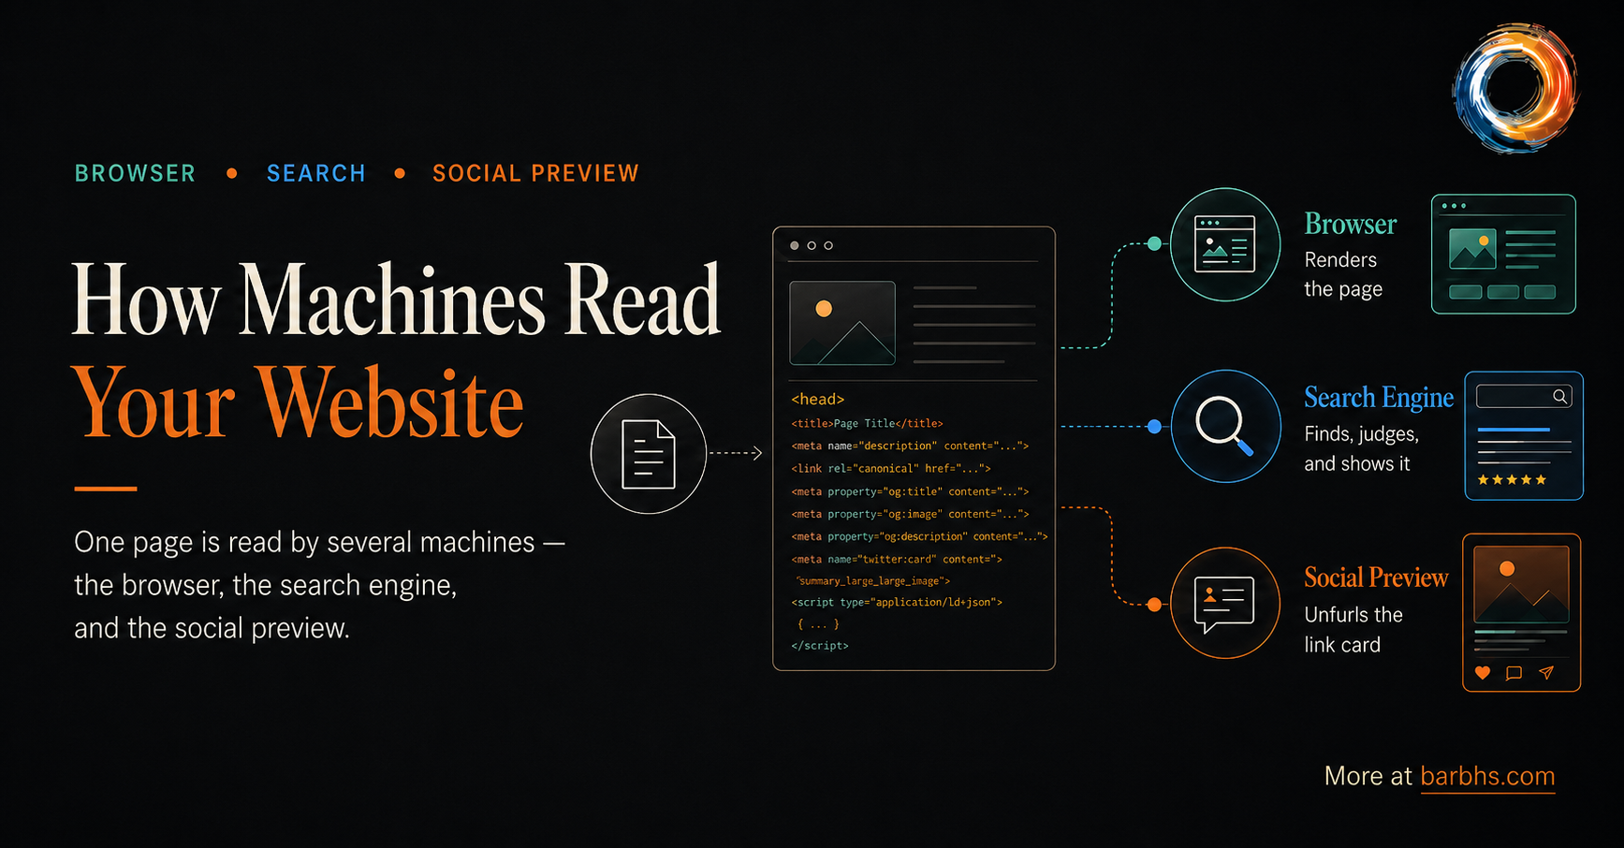

ALTERNATE HERO OR GRAPHIC
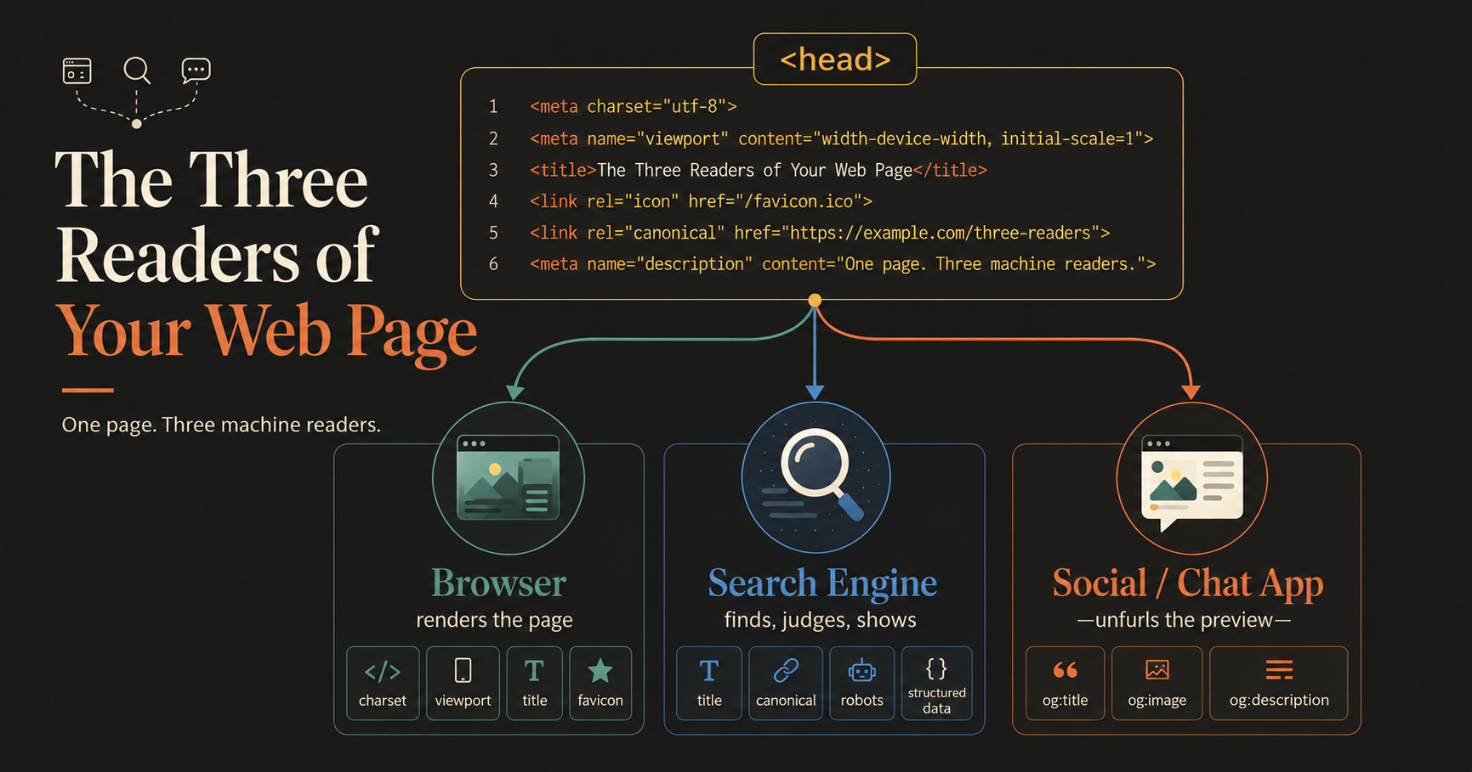

ALTERNATE HERO OR GRAPHIC
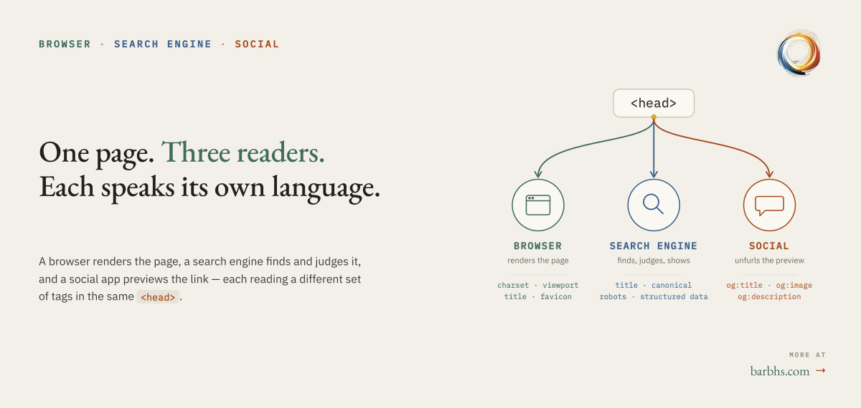

TO POST SOON: Evaluate AGENTS instruct w framewrk

What I Learned Writing 800 Lines of AI Instructions (And Why I Cut It to 650)
Reading Time: 8 minutes TL;DR: Created evaluation framework for AI instruction files, discovered mine was 25% too large, affecting performance. Scored 88/100. Here's what changed.

My CLAUDE.md file said "Last Updated: November 2025."

It was December 2024.

I stared at the screen. My AI instructions—the ones telling Claude Code how to work on my project—were lying to the AI. And if I couldn't keep one date field accurate, how was I supposed to maintain three different AI configuration files across three different tools?

That bug at 10 PM on a Tuesday became the catalyst for something bigger: a systematic framework for evaluating AI assistant instruction files.

Because here's what nobody talks about: we're all winging this.

The 800-Line Problem Nobody Warned Me About
Three months ago, I started building ChronoScope with Claude Code. One CLAUDE.md file. Simple.

Then I added Cursor for quick UI tweaks. Needed .cursorrules.

Someone mentioned AGENTS.md standard. Should I adopt it too?

Suddenly: three configuration files, three different AI tools, all trying to describe the same project. Every refactor meant updating three files. Every new pattern, three places.

And ChronoScope's CLAUDE.md kept growing. 400 lines. 600 lines. 800 lines.

Most developers I talked to had similar experiences but no one could answer: How do you know when your AI instruction file is helping vs hurting?

I needed a way to measure it.

What Research Revealed (Spoiler: Size Matters)
While searching for guidance, I found Anthropic's Claude Code best practices. One line stopped me:

"Frontier LLMs can follow ~150-200 instructions with reasonable consistency. Claude Code's system prompt already contains ~50 individual instructions."

Wait.

Claude Code: 50 instructions (baseline) My CLAUDE.md: ~150 instructions Total: 200 (right at the limit)

But that's just instruction count. The research also said:

- Token usage affects performance - Larger files = slower AI response
- Code style ≠ AI instructions - Use linters (Black, Prettier), not LLM prompts
- Start simple, expand organically - Don't pre-write before you code

I looked at my file again. Plotly tooltip font sizes? Pixel-perfect color codes? That wasn't AI instructions—that was design documentation disguised as AI instructions.

My 800 lines weren't helping. They were slowing everything down.

But how much? And what should I fix first?

I needed a framework.

Building a 100-Point Scoring System
Since no one else had created evaluation criteria for AI instruction files, I built one. Six categories, 100 points total:

The Framework
Category | Points | What It Measures
Structure & Organization | 20 | Can AI find info quickly? Clear sections? TOC?
Accuracy & Currentness | 20 | Working examples? No stale info? Correct paths?
Comprehensiveness | 20 | Architecture? Security? Troubleshooting covered?
Actionability | 20 | Copy-paste examples? Do/don't comparisons?
Information Balance | 10 | Right detail level? Not too verbose/sparse?
Usability for AI | 10 | Quick Start? Red Flags? Links to resources?

ChronoScope's CLAUDE.md: 88/100 (B+)

Not terrible. But that breakdown revealed specifics:

What Hurt the Score:

- Wrong "Last Updated" date: -5 points (Accuracy)
- Incomplete "Session State Management" stub: -3 points (Comprehensiveness)
- Missing security guidance: -2 points (Comprehensiveness)
- Overly detailed UI specifications: -2 points (Balance)

What Saved It:

- Streamlit Golden Rules section: Perfect actionability
- Red Flags guidance: Strong AI usability
- Clear examples throughout: High actionability
- Troubleshooting section: Comprehensive

The framework gave me concrete, prioritized improvements. Not "make it better"—but "add security section (critical), complete stub (high priority), simplify UI section (quality improvement)."

Six Insights That Changed My Approach

1. Conciseness Is Performance (Not Just Clarity)
Before: More documentation = better AI assistance After: Smaller files = faster AI, every token processed on every interaction

My 800 lines were computational overhead. Most of it unnecessary most of the time.

Action: Condensed 800 → 650 lines by moving detailed patterns to STREAMLIT_BEST_PRACTICES.md and referencing instead of duplicating. 25% reduction.

Performance impact: Noticeable. Claude Code responds faster when not parsing 200 extra lines about tooltip font sizes.

2. Code Style ≠ AI Instructions
The trap: Documenting everything including formatting preferences

Anthropic's wisdom: "Never send an LLM to do a linter's job"

My file had:

- Use 88-character line length

- Prefer double quotes

- Import order: stdlib, third-party, local

This is what Black, Prettier, ESLint are for. Deterministic tools. Not probabilistic LLM instructions.

Action: Deleted all style rules → Added one line: Run black . before committing

3. Red Flags Prevent Expensive Assumptions
Discovery: AI doesn't ask when unsure—it guesses confidently

I watched Claude Code make architectural decisions I never intended. Why? I never told it when to stop and ask.

Solution - Red Flags Section:

### Stop and Ask User When:

- Unclear requirements ("make it better")

- Multiple valid approaches (REST vs GraphQL)

- Database schema changes

- Breaking API changes

Impact: Transformed. Claude now asks instead of assumes. Saves hours of undoing confident wrong decisions.

4. Dates Are Promises You'll Break
The problem: "Last Updated: November 2025" in December 2024

Dates in documentation rot instantly:

- "As of Q4 2024" → stale in Q1 2025
- Example timestamps → AI thinks it's current date
- Version numbers → outdated with next release

Action:

- Removed "Last Updated" field
- Changed examples: "2024-12-30T10:00:00" → "ISO 8601 timestamp"
- Added: Review when major architectural changes occur (trigger-based, not time-based)

5. Start 50 Lines, Not 800
My mistake: Pre-writing comprehensive docs before feeling friction

Better approach: Start minimal, expand when you hit real problems

The best sections in my CLAUDE.md? Written after bugs. After team questions. After repeated frustrations.

If I started today (50-line template):

# ChronoScope - AI Instructions

## Quick Start

`pip install -e .` → `streamlit run app.py`

## Architecture

Streamlit → DocumentProcessor → LLM → TimelineStore

## Critical Rules

❌ NEVER: Add widgets without `key` parameter

✅ ALWAYS: Check `processed_files` cache

## Troubleshooting

"Module not found" → `pip install -e .`

## Resources

Detailed patterns: `STREAMLIT_BEST_PRACTICES.md`

Done. Everything essential, nothing more. Expand when friction occurs.

6. One Framework, Any Tool
Realization: Evaluation criteria are universal

Whether CLAUDE.md, AGENTS.md, or .cursorrules:

- Is it accurate? (Working examples, correct paths)
- Is it actionable? (Copy-paste ready, clear do/don't)
- Is it comprehensive without overwhelming? (Balance)
- Does it help AI work faster? (Performance)

The 6-category, 100-point framework works for any AI assistant instruction file.

What the Framework Revealed (The Specifics)
Applying my framework to ChronoScope exposed patterns I couldn't see before:

Structure (18/20): Good hierarchy, but missing TOC for 800-line file Accuracy (12/20): Wrong date (-5), unverified "current state" (-2), version assumptions (-1) Comprehensiveness (16/20): Missing security (-2), incomplete stub (-3), light error coverage (-1) Actionability (18/20): Excellent examples, strong do/don't patterns Balance (14/20): UI section too detailed (-3), uneven coverage (-3) AI Usability (19/20): Strong Quick Start, clear Red Flags

Total: 88/100 (B+)

The numbers made it obvious: Fix Accuracy first (biggest impact), then Comprehensiveness, then Balance.

What Changed (The After)

Before (800 lines, 88/100):
- "Last Updated: November 2025" ❌
- 50+ lines of pixel-perfect UI specs
- Incomplete "Session State Management" stub
- No security guidance
- 120+ lines of testing minutiae
- Redundant import pattern explanations

After (650 lines, estimated 94/100):
- No "Last Updated" field ✅
- UI section: 18 lines, references styles.py for details
- Session State: Completed with initialization patterns
- Security section: API keys, PII handling, privacy
- Testing: 35 lines, core concepts only, links to STREAMLIT_BEST_PRACTICES.md
- Removed dates from all examples

Performance Impact: Noticeable improvement in Claude Code response time. 25% fewer tokens to process on every interaction.

What Makes This Different from Other "AI Instructions" Posts
I searched for similar content. Found lots of "How I use Claude Code" posts. Found AGENTS.md explainers. Found tool comparisons.

What I didn't find:

- A scoring system for AI instruction files
- Performance impact quantified (token usage → speed)
- Before/after evaluation with specific scores
- Reusable framework applicable to any tool

Most posts share tips. This post shares a measurement tool.

Shrivu Shankar's "How I Use Every Claude Code Feature" mentions 13KB file size (could grow to 25KB). But what's the right size? How do you know?

The "Staff Engineer's 6-week journey" at Sanity.io shares project outcomes. But how do you evaluate the instructions themselves?

Multiple blogs explain AGENTS.md standard. But none provide evaluation criteria for whether your file—regardless of format—is actually good.

This framework fills that gap.

The Real Lesson: Documentation for Aliens
Writing 800 lines of AI instructions taught me something fundamental:

AI assistant configuration files are unlike any documentation I've written. They're not for users (docs/). Not for developers (README.md). They're for something else.

They're documentation for a non-human intelligence that:

- Reads everything you give it, every time (no memory)
- Has token limits affecting performance (not just comprehension)
- Processes language probabilistically (not deterministically)
- Needs explicit permission to ask questions (won't assume)

Same principles apply: DRY, maintainable, versioned Different constraints: Token efficiency, performance impact, precision

We apply human documentation practices but with alien constraints.

And we're all learning in real-time. AGENTS.md standard is six months old. Claude Code best practices published this year. Every AI instruction file is an experiment.

The question is: Are we learning from each other's experiments?

That's why I built the framework.

Try It Yourself (The Evaluation Worksheet)
Want to score your own CLAUDE.md / AGENTS.md / .cursorrules?

Quick Self-Evaluation (5 minutes):

- How many lines? (Count)

  - <100: Probably too minimal
  - 100-500: Sweet spot
  - 500-800: Questionable
  - 800+: Almost certainly too large

- Quick Checks:

  - Has "Last Updated" date? (Remove it)
  - Has pixel-specific UI specs? (Move to design doc)
  - Has code style rules? (Use linter instead)
  - Missing security section? (Add it)
  - Has "Red Flags" guidance? (Critical)

- The Token Test:

  - Your file instructions + Claude Code's 50 = ?
  - If >200: Too many instructions
  - Action: Split detailed content to separate files

Full Framework:

- Complete Evaluation Guide - 60+ pages, scoring rubric, templates
- Evaluation Worksheet - Print and score your file
- ChronoScope CLAUDE.md - See the "after" (650 lines, 94/100 estimated)

What's Next
I'm applying this framework to my second project (Resume Graph Explorer - React + Flask stack) to see if patterns hold across different tech stacks.

Hypotheses to test:

- Does React need different instruction patterns than Streamlit?
- Is 150-instruction limit universal or model-dependent?
- Do full-stack projects need longer files than single-stack?

I'll report back.

The Conversation I Want to Have
Tell me about your AI instruction files:

- How many lines? (Let's build a dataset)
- Multiple tools = multiple files? (How do you keep them in sync?)
- Biggest maintenance pain? (What's hardest about keeping instructions current?)
- Patterns that work really well? (Share your wins)
- Ever measured performance impact? (File size → AI speed)

What I'm sharing:

- Framework Guide - Full 100-point evaluation system
- Evaluation Worksheet - Score your own file
- ChronoScope Case Study - Detailed before/after

What I'm curious about:

- Has anyone else quantified this?
- Are there other frameworks out there?
- What am I missing?

We're figuring this out in real-time, together. Six months ago, AGENTS.md didn't exist. Who knows what we'll learn in the next six months?

Let's share notes.

(And if you spot a better approach? Tell me. I'll update my CLAUDE.md immediately. This time without adding a date that lies.)

Key Takeaways
✅ Performance: 800 lines → 650 lines = 25% faster AI response ✅ Framework: 100-point scoring system (6 categories) ✅ Score: ChronoScope 88/100 → 94/100 (estimated) ✅ Red Flags: Explicitly tell AI when to ask user (game-changer) ✅ Dates: Remove them entirely (they go stale instantly) ✅ Start Small: 50-line minimal template, expand organically ✅ Reusable: Framework works for CLAUDE.md, AGENTS.md, .cursorrules, any tool

Research Sources:

- Claude Code Best Practices (Anthropic)
- How I Use Every Claude Code Feature (Shrivu Shankar)
- AI Coding Assistants for Large Codebases (Augment Code)
- Keep your AGENTS.md in sync (Kaushik Gopal)

Found this useful? Think I'm missing something obvious? Let's talk in the comments.

✅ Posted 2026-07-01 | Missing Layer, KPMG and Glean
LinkedIn Article, published 2026-07-01 | On my website | On LinkedIn

The Missing Layer Between AI Adoption and AI value
Copilot can save a person an hour. Where does that hour go?

I read KPMG’s AI Pulse Q2 2026 alongside Glean’s Work AI Index because they look at the same enterprise AI problem from different ends of the workflow.

Leaders are asking about ROI, accountability, governance, and cost visibility.

Workers are dealing with the last mile: finding context, checking outputs, rerunning prompts, and cleaning up work that looked finished.

The tension shows up clearly in Glean’s numbers: 11 hours saved per week, and 6.4 hours spent supervising and repairing the work AI produced.

That’s too much 𝗵𝗶𝗱𝗱𝗲𝗻 𝗹𝗮𝗯𝗼𝗿 to treat as a user-training footnote.

AI can draft the work. But the organization still has to decide who owns it, what context it depends on, what quality bar it has to meet, what it costs to supervise, and when a person should override it.

The cost doesn’t disappear. It moves.

Into downstream review.
Into quiet cleanup.
Into polished work someone has to trust, challenge, or redo.

The layer between individual AI use and organizational value is made of very practical things:
• accountability
• shared context
• quality control
• cost visibility
• work design
• human judgment

I made a short PDF companion with the test I’d use on any AI-assisted workflow.

Pick one real workflow and ask:
□ Who owns the decision?
□ What does it cost to run?
□ What context does it need?
□ What quality bar must it meet?
□ Who can explain, challenge, or override the output?

𝗨𝗻𝗮𝗻𝘀𝘄𝗲𝗿𝗲𝗱 𝗾𝘂𝗲𝘀𝘁𝗶𝗼𝗻𝘀 𝗵𝗲𝗿𝗲 𝗮𝗿𝗲 𝗶𝗻𝘁𝗲𝗴𝗿𝗮𝘁𝗶𝗼𝗻 𝗽𝗿𝗼𝗯𝗹𝗲𝗺𝘀, even when adoption looks strong.

I’ll put the full post in the first comment.

#AIGovernance #AIAdoption #EnterpriseAI #AIReadiness #ResponsibleAI

✅ Posted 2026-06-26 | Article & Post - AI Skills Gap
LinkedIn Article, published 2026-06-26 | On my website | On LinkedIn

What Looks Like an AI Skills Gap Is Often a Judgment Gap
When I built and deployed my Digital Twin — a system designed to answer questions from my own body of work — the chatbot was the part people noticed. The evaluation layer around it was the part that earned the result.
The chatbot could answer questions, which was exciting. But that was not enough. I needed to know what it had retrieved, whether the source actually supported the response, whether the answer sounded right for the wrong reason, and whether a better model, prompt, or retrieval backend had made the system better at the job — or merely better at sounding like it was.
That is the hidden work behind useful AI systems. It is tempting to focus on the visible interaction: the prompt, the answer, the clean little paragraph that comes back. But the quality of that answer depends on decisions made before the prompt ever runs: what counts as the right source, what a good response has to account for, what errors matter, and who owns the call when the system sounds confident.
That lesson travels far beyond one Digital Twin. It shows up anywhere teams are trying to use AI on top of real organizational knowledge. A system can retrieve, summarize, classify, and draft at impressive speed. But speed does not tell you whether it understood the job. The point is NOT that every team needs an elaborate evaluation harness. The point is that every serious use of AI needs some way to define what good means before fluency starts passing for evidence.
That’s why I have come to think of AI literacy as a judgment problem first and a tool problem second.

Tool fluency is table stakes
A lot of AI training begins at the tool. Open this, choose that model, phrase the request this way. People do need that, and it's worth teaching. But knowing how to operate a tool tells you nothing about whether you aimed it at the right problem, whether you'd catch it inventing a citation, or whether the decision belonged to a machine in the first place. That is a separate skill, and no tool hands it to you.

Speed magnifies whatever you bring to it
Here is what speed does to that skill. I recently built a system that answers questions in one specific person's voice and body of work — mine. To run it in production, I needed to choose between two models, so I scored both on the same 58 questions. Both wrote fluently. Both sounded confident. Judged on the prose alone, I could have defended either choice.

What separated them only surfaced once I'd gotten specific about what a good answer had to do: hold the right voice, ask a follow-up where a real conversation would, surface the right work at the right moment. I learned to get specific the hard way — by shipping first and watching a fluent answer mislead me before I'd defined what 'good' actually meant. Without evaluation criteria, I picked whichever read better that afternoon, and that’s how I got burned.

The same dynamic scales up. Aim a model at a well-framed problem and it compresses good thinking into minutes. Aim it at a vague one and it compresses just as quickly, toward a fluent answer that happens to be confidently wrong, which you now have to catch after the fact instead of before. The acceleration doesn't change. The framing decides where it carries you.

[FIGURE 1 HERE]

The missing layer
It helps to picture AI literacy as a stack of three tiers, each with a different shelf life.

At the base is capability: choosing a tool, getting a problem into a form the model can work with, and repairing a workflow when a multi-step process breaks. This is what most training covers. It is necessary, and it is the part the tools themselves keep absorbing.

In the middle is judgment: framing the problem before reaching for anything, and evaluating what comes back, including when a clean and confident answer has earned trust and when it hasn't. This is the scarce tier, scarce because no tool supplies it for you.

At the top is governance: deciding what stays human-led at all. Where accountability can't be handed off, where being confidently wrong is too expensive, where a person owns the result regardless of what the system produced. A model can draft the analysis, summarize the record, or compare options; it cannot own the consequence of acting on a bad recommendation.

[FIGURE 2 HERE]

Tool training runs bottom-up and tends to stop at the first tier. I believe AI literacy training should run the oppposite direction: start at the top, with the stakes and the problem, and treat the tool as the last thing you pick up.

The questions that do the work
In practice, judgment comes down to a few questions asked before the prompt box is even open:

- What am I actually trying to decide, understand, or create?
- What would a genuinely good answer have to account for?
- What part of this should stay human-led?
- How will I know whether the output is any good?
- What does it cost me to be confidently wrong here?

None of them is about prompting. They are what tell you whether the prompt is worth writing, and later, whether the answer it produced deserves to be used.

The literacy worth building
I work with these tools every day and I'm glad they're this good. But the teams getting the most from AI are not simply the ones moving fastest. They are the ones that can sit with a half-formed problem long enough to frame it well, then look at a confident output and still ask whether it is right.

That is the literacy worth building: not just the ability to use the tool, but the judgment to know when its answer has earned trust.

I’m building more of this work at barbhs.com — practical frameworks for AI literacy, judgment, governance, and knowledge systems that help teams use AI without confusing fluency for correctness.

Figure 1. The same tool can accelerate good framing or vague framing. The speed is not the differentiator; the frame is.
Alt text: Diagram showing that the same AI tool produces different outcomes depending on how the problem is framed. A well-framed problem with clear goals, constraints, and success criteria leads to useful work sooner. A vague problem with unclear goals, missing criteria, and no check leads to a fluent but wrong result.

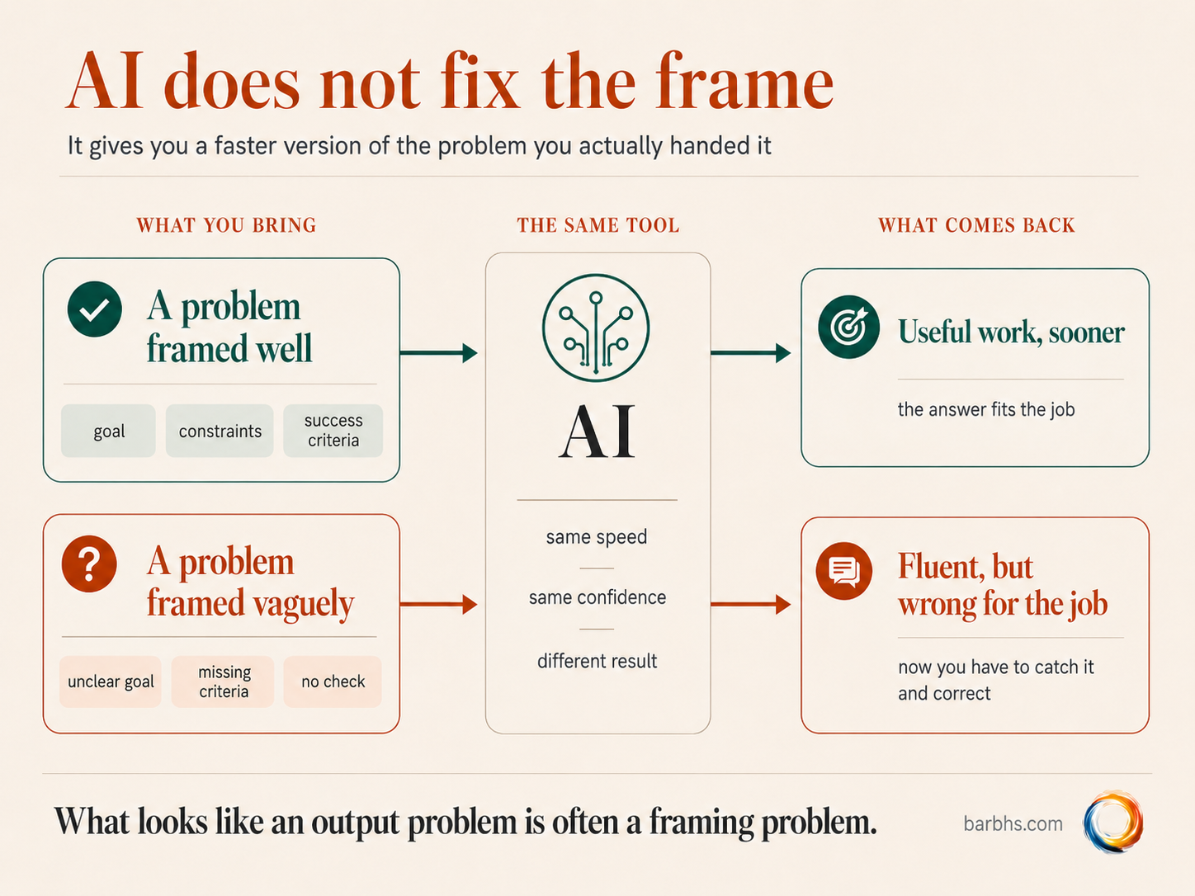

Figure 2. AI literacy has a tool layer, but the durable value lives in judgment and governance.
Alt text: Diagram showing AI literacy as a three-layer stack: capability at the bottom, judgment in the middle, and governance at the top. Capability includes tool choice, structuring the task, and workflow debugging. Judgment includes problem framing, output evaluation, and cost of error. Governance includes accountability, who decides, and high-stakes calls.

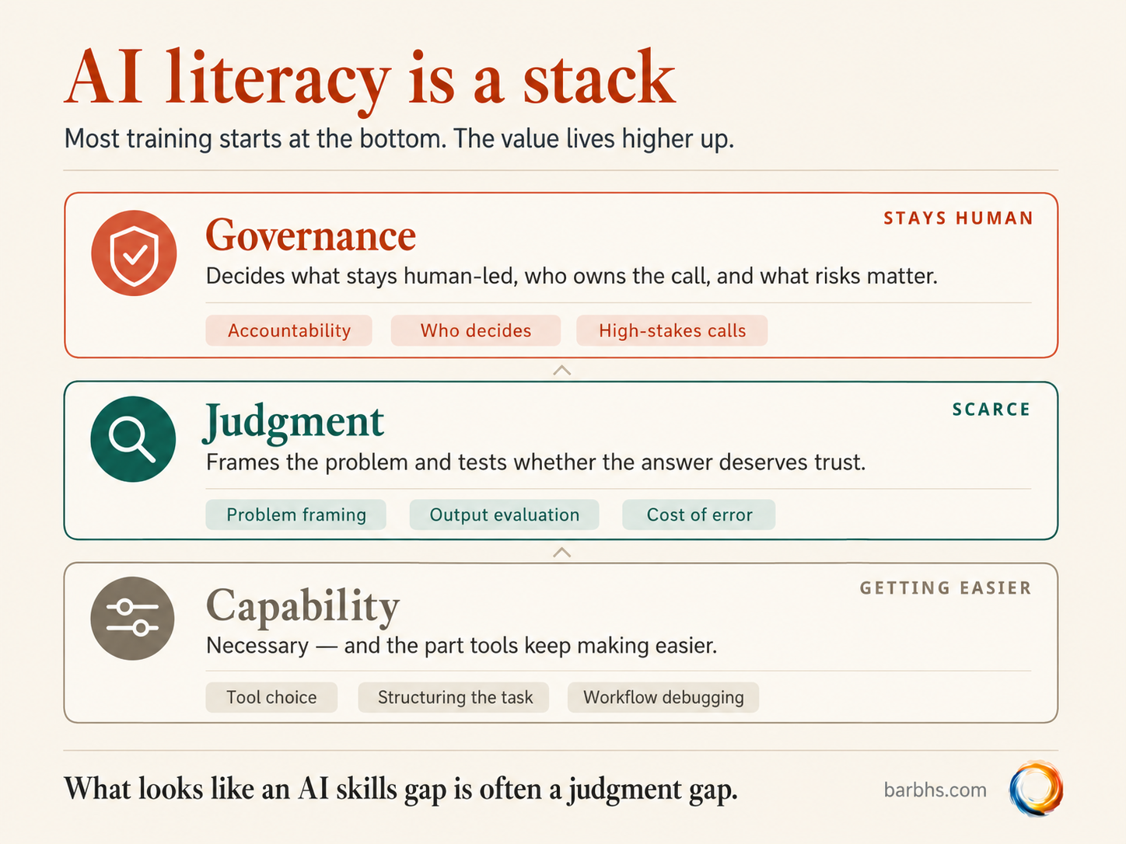

HERO IMAGE
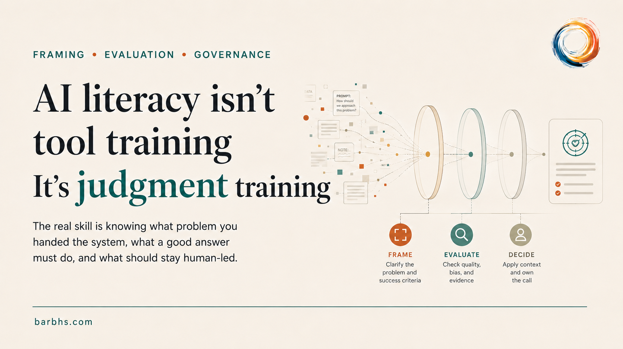

FINAL VERSION of a regular LinkedIn post to drive folks to the article:
The hardest part of my recent AI build wasn’t building the chatbot.
It was deciding what a good answer actually was.
The system was my Digital Twin: a tool designed to answer questions from my own voice and body of work. To run it responsibly, I had to choose between two models, so I scored both on the same 58 questions.
Both were fluent.
Both sounded confident.
Judged on the writing alone, I could have defended either one.
And that was exactly the trap.
What separated them only became visible after I got specific about what a good answer had to do:
→ hold the right voice
→ ask a follow-up where a real conversation would
→ surface the right work at the right moment
→ stay grounded in the source, not just sound plausible
Without those criteria, I was measuring my taste in prose – not the system.
That's the part that gets skipped when "AI literacy" means "tool training." Knowing how to use the tool is table stakes. The durable skill is judgment: framing the problem before you reach for the tool, and knowing whether the answer that comes back earned its trust.
Same trap waiting anywhere a team points AI at its own knowledge.
I wrote more about this in a LinkedIn article today:
What Looks Like an AI Skills Gap Is Often a Judgment Gap
Article link in the comments 👇
#AILiteracy #AIGovernance #AIAdoption

✅ Posted 2026-06-05
I kept hearing the word “𝐡𝐚𝐫𝐧𝐞𝐬𝐬” everywhere in AI lately.

Evaluation harness.
Agent harness.
Readiness harness.
Judge harness.
Fuzzing harness.

At some point I had to ask:

𝐖𝐚𝐢𝐭 — 𝐚𝐫𝐞 𝐭𝐡𝐞𝐬𝐞 𝐚𝐥𝐥 𝐭𝐡𝐞 𝐬𝐚𝐦𝐞 𝐭𝐡𝐢𝐧𝐠?

Kind of. Not exactly.

The word is carrying useful baggage from several technical traditions: software testing, agent runtimes, release engineering, LLM-as-judge evaluation, and fuzzing/security work.

And it became especially relevant while I was building a more systematic evaluation setup for my own Digital Twin.

So before I share more about that eval harness — 24 core questions, 10 smoke tests, and some interesting model/backend results 🧪 — I made a quick visual decoder.

The gist:
→ 𝐌𝐨𝐝𝐞𝐥𝐬 𝐩𝐫𝐨𝐯𝐢𝐝𝐞 𝐜𝐚𝐩𝐚𝐛𝐢𝐥𝐢𝐭𝐲.
→ 𝐇𝐚𝐫𝐧𝐞𝐬𝐬𝐞𝐬 𝐦𝐚𝐤𝐞 𝐭𝐡𝐚𝐭 𝐜𝐚𝐩𝐚𝐛𝐢𝐥𝐢𝐭𝐲 𝐮𝐬𝐚𝐛𝐥𝐞.

LinkedIn post | Infographic PNG

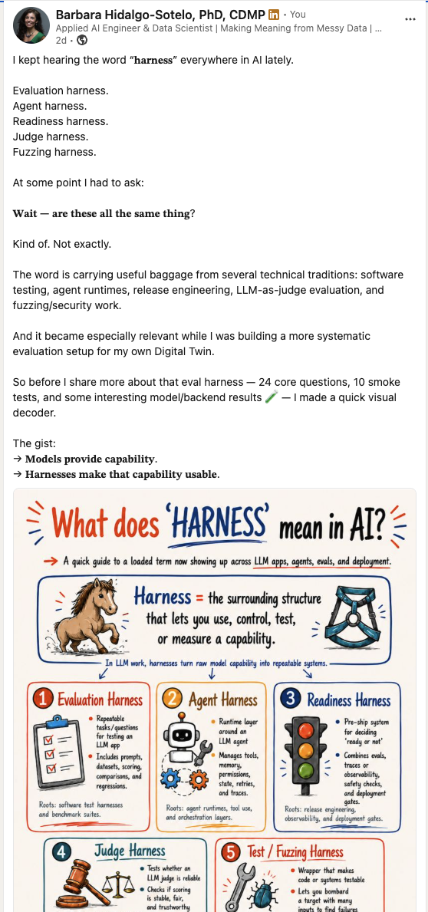

✅ Posted 2026-06-07
𝗠𝗲𝗺𝗼𝗿𝘆 𝗶𝘀 𝗻𝗼𝘁 𝘀𝘁𝗼𝗿𝗮𝗴𝗲.
It’s how the past becomes usable in the future.
I’ve been thinking about that while restructuring memory in one of my own AI systems.
Saving documents is easy. The harder questions are:
What’s worth keeping?
What should it connect to?
When should it come back?
What needs to change when new evidence arrives?
What can safely be forgotten?
A recent arXiv preprint from researchers at the MIT Media Lab tested one narrow case: essay writing with ChatGPT.
The ChatGPT group showed lower EEG connectivity, had more trouble recalling their own text, and reported less ownership of the work.
That’s not proof that AI “damages memory.” The study was small, task-specific, and some of its methodological choices have been challenged.
But it does help me articulate the question I care about:
What happens when assistance arrives before we’ve done enough of the encoding and organizing to make the knowledge our own?
Agents run into a different failure: 𝗿𝗲𝗺𝗲𝗺𝗯𝗲𝗿𝗶𝗻𝗴 𝗲𝘃𝗲𝗿𝘆𝘁𝗵𝗶𝗻𝗴 𝗶𝘀𝗻’𝘁 𝘁𝗵𝗲 𝘀𝗮𝗺𝗲 𝗮𝘀 𝗹𝗲𝗮𝗿𝗻𝗶𝗻𝗴.
A store full of stale facts, contradictions, and outdated state can make an agent less reliable, not more.
𝗙𝗼𝗿 𝗵𝘂𝗺𝗮𝗻𝘀, 𝗮𝘀𝘀𝗶𝘀𝘁𝗮𝗻𝗰𝗲 𝗰𝗮𝗻 𝗼𝘂𝘁𝗿𝘂𝗻 𝗲𝗻𝗰𝗼𝗱𝗶𝗻𝗴.
𝗙𝗼𝗿 𝗮𝗴𝗲𝗻𝘁𝘀, 𝘀𝘁𝗼𝗿𝗮𝗴𝗲 𝗰𝗮𝗻 𝗯𝘂𝗿𝘆 𝘁𝗵𝗲 𝘀𝗶𝗴𝗻𝗮𝗹.
Different systems, different risks—but a shared design pressure:
𝗠𝗲𝗺𝗼𝗿𝘆 𝗮𝗿𝗰𝗵𝗶𝘁𝗲𝗰𝘁𝘂𝗿𝗲 𝗺𝗮𝘁𝘁𝗲𝗿𝘀.
Useful memory needs more than capacity. It needs selection, structure, retrieval, revision, and forgetting.
The question isn’t whether we should outsource memory. Humans have always done that.
It’s whether we can name what we’re handing over—recall, organization, judgment, or even a sense of ownership—and then design deliberately for what stays human, what becomes machine-assisted, and what needs a better architecture.
Still thinking this through. I’d love to hear where this framing holds—and where it breaks.
Research links in the first comment.
#CognitiveScience #AIAgents #MemoryArchitecture

LinkedIn post | Infographic PNG
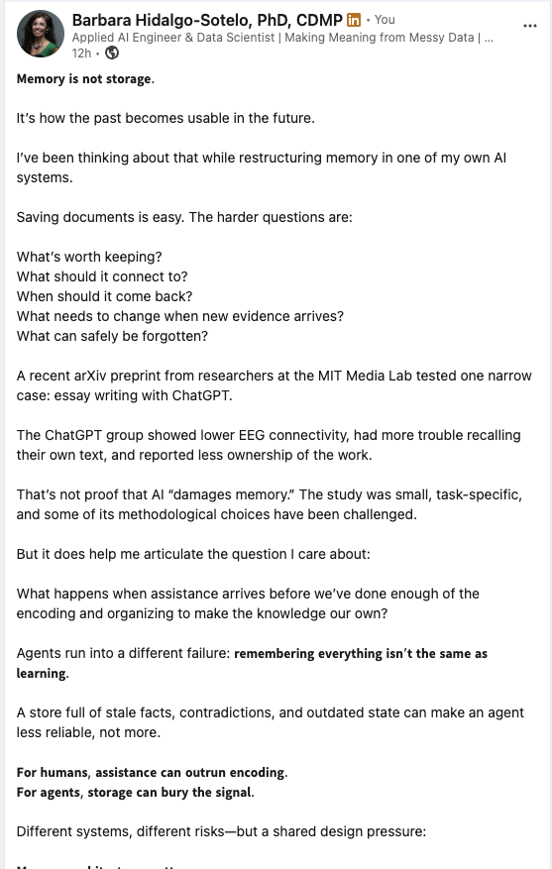

COMMENT #1
A few sources for anyone who wants to follow the two threads behind this post:
Human learning and AI-assisted writing:
• “Your Brain on ChatGPT: Accumulation of Cognitive Debt when Using an AI Assistant for Essay Writing Task”
https://arxiv.org/abs/2506.08872
• A constructive methodological commentary on that preprint
https://arxiv.org/abs/2601.00856
Long-term memory for AI agents:
• “SAGE: A Self-Evolving Agentic Graph-Memory Engine for Structure-Aware Associative Memory”
https://arxiv.org/abs/2605.12061
• “Is Agent Memory a Database? Rethinking Data Foundations for Long-Term AI Agent Memory”
https://arxiv.org/abs/2605.26252
The papers are quite different, and I’m not suggesting that human and agent memory are equivalent systems. What interests me is the shared pressure around selection, retrieval, revision, and forgetting.

✔️ 2025-05-2026
𝗧𝗵𝗲 𝘀𝗸𝗶𝗹𝗹 𝘂𝗻𝗱𝗲𝗿𝗻𝗲𝗮𝘁𝗵 𝗴𝗼𝗼𝗱 𝗔𝗜 𝘂𝘀𝗲 𝗶𝘀 𝗼𝗹𝗱𝗲𝗿 𝘁𝗵𝗮𝗻 𝗔𝗜 𝗶𝘁𝘀𝗲𝗹𝗳.
Most AI training teaches you to use the tools. It teaches the wrong layer. The skill that actually determines whether AI gets used well is harder to name, and almost entirely absent from current curricula. It has two layers — a perceptual foundation underneath, and an architecture of mental models and workflows on top.
I sketched what that looks like.
The bottom layer is what cognitive scientists have studied for decades: how attention catches what matters when there's too much information to process.
It's what determines whether you notice the AI output is 𝘴𝘶𝘣𝘵𝘭𝘺 𝘸𝘳𝘰𝘯𝘨 before you act on it — or whether you don't.
The top layer is what teams actually navigate: decomposing vague goals, choosing representations that hold up under pressure, debugging misalignment between what AI produced and what the organization actually needed.
Both layers are teachable. 𝗔𝗹𝗺𝗼𝘀𝘁 𝗻𝗼 𝗼𝗻𝗲 𝗶𝘀 𝘁𝗲𝗮𝗰𝗵𝗶𝗻𝗴 𝘁𝗵𝗲 𝗯𝗼𝘁𝘁𝗼𝗺 𝗼𝗻𝗲.
𝘔𝘰𝘳𝘦 𝘢𝘵 𝘴𝘦𝘯𝘴𝘦𝘮𝘢𝘬𝘪𝘯𝘨-𝘢𝘪.𝘤𝘰𝘮

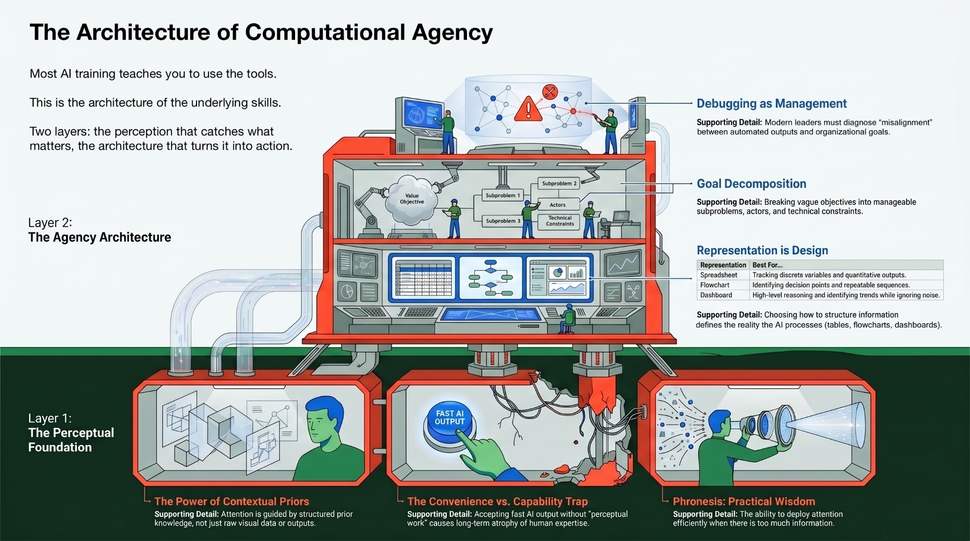

Link to post
Published 5/4/2026

OTHER DRAFTS:
Most AI training still starts in the wrong place.
It teaches people how to use the tools.
That matters, of course. But it skips the harder question:
What are the underlying skills people need to work well with AI when the work is messy, ambiguous, and consequential?
I keep coming back to the idea of computational agency: the ability to frame problems, choose useful representations, debug workflows, evaluate outputs, and know where human judgment has to stay in the loop.
This infographic is my attempt to make that idea more concrete.
There is a perceptual layer: what we notice, what prior knowledge we bring, what we accept too quickly.
Then there is an architecture layer: how we break goals down, represent information, diagnose misalignment, and turn vague intentions into usable systems.
The point is not that everyone needs to become an AI engineer.
The point is that more people need the mental models to understand what AI is doing, where it fits, and when it should not be trusted.
That is the space I’m exploring with Sensemaking AI.
Source: ChatGPT convo

〰️ -----------------------------

🤔 -- PLANNING NOTES --

The short version
The whole field is being pulled into the open by the same force at once: LLMs are bad at facts, and knowledge graphs are the thing people are bolting on to fix that. Gartner placed GraphRAG on its gen-AI hype cycle and estimates two to five years to maturity, which is the sweet spot for your timing — past "nobody's heard of it," well before "saturated and boring." Every one of your four audiences is converging on the same realization from a different side of the building. CIO

The four doors, with what I found behind each
AI builders and data engineers. This is the loudest and fastest-moving room. GraphRAG combines knowledge graphs with retrieval to help systems reason over how facts connect, not just retrieve isolated ones, and the reported accuracy gains are real but come with a catch worth your honest voice: it shines on multi-hop questions but adds wasteful overhead for simple lookups like "what's the CEO's name". The job market is following — postings for senior knowledge-graph engineers and graph-RAG product roles at places like JPMorgan are live right now, and they ask for semantic web technologies, data modeling, SPARQL, and ontology design in the same breath. There's also a newer, sharper version of this door: agents hit the wall of finite context windows, and the frontier fix is treating a knowledge graph as a persistent, evolving memory substrate rather than static storage. That agent-memory framing is the most 2026 thing in the whole search. Articsledge + 3
The semantic web community itself. Smaller, expert, and pivoting hard toward exactly your intersection. DBpedia and SEMANTiCS ran sessions on how LLMs can benefit from structured knowledge and how to make linked data trustworthy for AI, and there's a whole benchmark line of work asking, almost literally, how well LLMs can write Turtle and generate SPARQL. These aren't newcomers — they're your peers, and they'll judge your rigor. They're a credibility audience, not a conversion audience. w3arXiv
Library and information science. This is the door I'd underweighted and now think is your highest-affinity underserved group. Librarians are being told plainly that linked data is how they stay relevant: OCLC is adding WorldCat entity URIs directly into MARC records to bridge catalog data into linked data and AI workflows, and the emerging role titles are things like knowledge architect and taxonomist, curating RAG corpora, metadata, and provenance standards. They already think in your terms — "this work is about that concept, by this person" is a triple — but most are light on the formal stack and there's far less good public material aimed at them than at the AI crowd. Your SKOS, provenance, and reification content speaks directly to their world. OCLCCriminallawlibraryblog
Curious newcomers riding the trend. Real but noisy. Coursera's knowledge-graph catalog is now dominated by RAG, vector databases, embeddings, and LangChain bundles — the on-ramp market is crowded and mostly tool-tutorial-shaped, not understanding-shaped. The honest skeptic's note also lives here, and you should keep it: one analyst with two decades in the space basically said knowledge graphs have been "the next big thing" for half his career and aren't for the faint of heart. Your "I'm not betting on RDF winning the web" honesty is the antidote to the hype-cycle fatigue these folks already feel. Coursera

Cold-open angles to brainstorm
The grounding-pain open (AI builder, my pick to lead): start with the felt failure. An LLM confidently gives a wrong answer — not because it lied, but because it has no model of what's true, only what's probable. The thing everyone's reaching for to fix that has a name people say a little nervously. Then the turn: to ground a model in facts, you first have to write facts down in a shape a machine can follow.
The invisible-win open (broad, drive-by friendly): you already live in this and didn't notice. When you ask how tall a building is and get the answer instead of ten blue links, when a Wikipedia infobox just knows — that's a knowledge graph. The semantic web didn't fail; it went invisible and won in narrow places. LLMs are now dragging it back into the open.
The agent-memory open (cutting edge): your agent forgets everything the moment its context window fills. The most interesting fix in 2026 isn't a bigger window — it's giving the agent a graph as memory, so it can hold who-relates-to-what across sessions. And here's the part a cognitive scientist can't resist saying: that's just associative memory with URIs.
The librarian open (underserved, high-conversion): if you've ever built a taxonomy or assigned a subject heading, you already think in triples — you just never had the syntax. For thirty years your field has been encoding exactly the structure LLMs are now starving for. This is flattering and true, and it would land hard with a population almost nobody is courting well.
The provenance open (trust): in a feed full of AI slop, the rarest thing is a fact you can trace — who said it, where, when, how sure. That's not a vibe, it's a data structure. This one previews your Module 3 reification work and your Itachi example without spending it.

Why care about any of this? – This is the next blog for my website
Try this. Picture someone you know, then the person who introduced you, then where the two of you first met, then who else was there. You just walked a chain of connections without effort — four hops, no strain. Now ask your tools the same shape of question. Your photo app can find "beach" but not "the trip where I met Sam." A spreadsheet can list your jobs but can't tell you which of your skills keep resurfacing across them. The facts are all there. They're just stored as boxes — rows, cells, folders — and boxes can't follow a chain.
There's a whole discipline for storing the connections instead of the boxes, and it's quietly everywhere already. When you ask how tall a building is and get the answer instead of ten blue links, that's it working. It spent two decades mostly invisible — and then we started building machines that are fluent, confident, and quietly wrong, and the missing piece turned out to be a way to write down what's actually true in a shape a machine can follow. That's why a twenty-year-old idea is suddenly the thing everyone's reaching for. This module is about the moment you stop fighting your box-shaped tools and start storing the connection itself.
You probably arrived through one of these:
- You've watched an AI system state something false with total confidence, and you've heard people mutter "knowledge graph" as the fix — and you'd like to know what they actually mean.
- You've spent years describing what things are about and how they relate — cataloging, taxonomies, metadata — and you're starting to suspect that structure is exactly what these AI systems are starving for. (You're right.)
- The words keep scrolling past — GraphRAG, ontology, RDF, SPARQL — and you'd rather understand them than nod along.
- You build things, and you have a hunch that how a system represents what it knows quietly decides what it can do. You want that tradeoff in your hands, not just on a slide.
All four roads meet in the same place, so this module uses one running example to get everyone there: a knowledge graph I built of the Naruto universe — 87 characters, who trained whom, who belongs to which village, who's related to whom. Small enough to hold in your head, tangled enough to stay interesting, which is what you want when the ideas are new. (Pop-culture domains are standard here for that reason — the canonical ontology tutorial is about pizza toppings.)
By the end, you'll be able to write a fact down as a connection a machine can follow, ask questions that chase those connections across the data, borrow the world's facts from public graphs like Wikidata, and — the consultant's move — tell which problems actually want this shape and which don't. The submodules below take you there one step at a time.

References:
- https://claude.ai/chat/b72fa620-4d4f-47c6-917e-f4975671f1a8

✍️ ** Ideas for Articles - 3rd Wk of June **
Thought leadership Fridays: Find the KPMG study and post it’s findings in a nice, interactive, Sensemaking-AI style HTML file
- Link here

“Opportunity AI” vs “Efficiency AI”
These three ideas actually form a coherent intellectual territory, not just three separate articles. The deeper theme is:
In an age of fast answers, human growth depends on judgment, friction, safety, and the ability to stay with complexity long enough to understand it.
he arc becomes: people need room to learn → AI literacy is judgment training → judgment requires knowing what not to outsource.
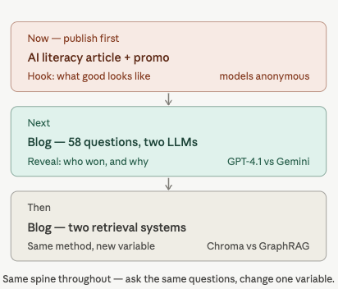

THEN:
Blog title: What I Learned Running 58 Questions Through Two LLMs
Blog text: https://barbhs.com/blog/twin-evaluate-models/
Accompanying HTML: https://barbhs.com/compare-models/

Blog title: What Happened When I Asked the Same Questions of Two Retrieval Systems
Blg text: https://barbhs.com/blog/twin-graphrag-migration/
Accompanying HTML: https://barbhs.com/graphrag-reference/
**** Be sure to correct the “50 question” to “58”

NEXT, the other two on each side:
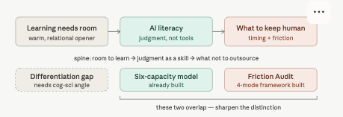

1. “Learning Needs Feedback. People Need Room.”
This is the most immediate and human of the three. It starts from today’s post, but it can become something bigger than “be nice to people.”
The real article is about the conditions under which feedback can actually be metabolized.

Core thesis
Feedback is essential to learning, but feedback does not land in a vacuum. It lands inside a nervous system, a relationship, a culture, and a moment.
People need error signals, yes. But they also need enough safety, dignity, and room to stay open.

What it could become
This could be a short, beautiful LinkedIn Article about feedback, psychological safety, parenting, teaching, leadership, and AI-era learning. It would not need to be heavily researched. It should feel reflective, warm, and grounded.
Possible angle:
We talk a lot about feedback as if it were just information. But feedback is also an event between people. The same correction can either help someone grow or teach them to shrink, depending on the conditions around it.

Possible structure
Opening:
Learning needs feedback. People need room.
Section 1: Feedback is not the enemy
You believe deeply in feedback. In sports, school, work, parenting, therapy, AI evaluation — growth depends on noticing gaps between what happened and what was intended.
Section 2: But feedback is not just data
For people, an error signal is never only an error signal. It arrives with tone, timing, power, history, trust, and context.
Section 3: Constant correction can make people less learnable
When people feel constantly edited, they may become more guarded, less playful, less curious, less willing to risk.
Section 4: Room is not passivity
Giving people room does not mean withholding all feedback. It means discerning whether the moment calls for correction, witnessing, curiosity, or simply letting someone be.
Section 5: A small practice
Before correcting, ask:
“Is this the moment for feedback, or is this the moment to protect the spark?”

Strong title variations
- Learning Needs Feedback. People Need Room.
- Not Every Moment Needs to Become a Coaching Opportunity
- Feedback Lands Inside a Relationship
- The Quiet Skill of Knowing When Not to Correct

Best use
This is a great first LinkedIn Article because it’s alive, readable, and not too big. It also signals something important about you: you can think rigorously without losing the human layer.

2. “AI Literacy Isn’t Tool Training. It’s Judgment Training.”
This is the most strategically important one.
This should become your flagship profile article. The one you pin in Featured. The one that says, “Here is how I think, here is what I build, here is what I care about.”
It directly supports Sensemaking-AI, your portfolio, your curriculum, your consulting identity, and your job-search positioning.

Core thesis
Most AI literacy training teaches people how to use tools. But the harder, more important skill is learning how to think while using them.
AI literacy is not just prompt fluency. It is judgment under conditions of speed, uncertainty, automation, and persuasive fluency.

What it could become
This could be your “professional manifesto,” but grounded and practical. Not dramatic. Not anti-AI. Not hype.
More like:
The question is no longer simply, “Can you use AI?”
The question is, “Can you preserve and strengthen judgment while using AI?”
That line is a keeper.

Possible structure
Opening:
Most AI training starts too late. It begins with the tool. But the real work begins before the tool: with the problem, the context, the stakes, and the human judgment required.
Section 1: Tool training is necessary but insufficient
People do need to know how to use ChatGPT, Copilot, Claude, Gemini, agents, RAG systems, etc. But that’s capability, not wisdom.
Section 2: Judgment is the missing layer
Judgment means knowing what problem you’re solving, what should not be automated, what evidence matters, when to distrust an answer, and when human accountability cannot be delegated.
Section 3: AI makes bad judgment faster
This is a strong section. AI can accelerate good thinking, but it can also accelerate unclear thinking. If the problem is poorly framed, the output may be fluent but misdirected.
Section 4: The six capacities of AI literacy
This is where your existing Sensemaking-AI model comes in beautifully:
- Problem framing
- Representation
- Tool choice
- Workflow debugging
- AI judgment
- Governance
Section 5: Practical takeaway
Before using AI, ask:
- What am I actually trying to decide, understand, or create?
- What would a good answer need to account for?
- What should remain human-led?
- How will I know whether the output is good?
- What are the risks of being confidently wrong?

Strong title variations
- AI Literacy Isn’t Tool Training. It’s Judgment Training.
- Most AI Training Starts in the Wrong Place
- The Missing Layer in AI Literacy
- AI Fluency Is Not the Same as AI Judgment
- Learning to Think While Using AI

Best use
This should probably be your Featured LinkedIn Article. It is the cleanest bridge between your cognitive science background, AI/data work, and Sensemaking-AI brand.
This is also highly reusable: website essay, LinkedIn article, YouTube script, carousel, talk proposal, portfolio intro, even a consulting one-pager.

3. “The Hidden Skill in the Age of AI: Knowing When Not to Outsource Your Thinking”
This is the deepest and probably the most original of the three, but it needs more research and care.
It is not just “don’t use AI too much.” That’s too simple.
The richer idea is:
The skill is not refusing AI. The skill is knowing which parts of thinking are safe to delegate, which parts must stay human-led, and which parts need to happen before the machine enters the room.
That is really good.

Core thesis
AI can help us think, but it can also let us skip the very friction that develops understanding. The future skill is not “use AI for everything” or “avoid AI to stay pure.” It is discernment.

What it could become
This could become a more research-backed article about cognitive offloading, desirable difficulty, automation bias, expertise, metacognition, and “productive friction.”
This is where you can bring in tangible tips.

Possible structure
Opening:
The hidden skill in the age of AI may not be prompt engineering. It may be knowing when not to prompt yet.
Section 1: AI changes the timing of help
Before, you had to sit with a problem longer. Now, you can get a fluent answer immediately. That’s powerful, but it changes the learning process.
Section 2: Some friction is waste; some friction is formative
This is the heart of the piece. Not all difficulty is good. But not all ease is good either.
Some friction clarifies the problem. Some exposes assumptions. Some builds internal models. Some gives you a chance to notice what you don’t understand.
Section 3: Outsourcing too early can weaken judgment
If you ask AI before forming your own model, you may inherit its framing, its categories, its blind spots, and its false confidence.
Section 4: What to outsource vs. what to keep
This could become an excellent practical framework:
Good candidates for AI help:
- summarizing known material
- generating alternatives
- finding gaps
- translating between levels of explanation
- checking consistency
- drafting once the core idea is yours
Be careful outsourcing:
- problem framing
- moral judgment
- final evaluation
- decisions involving people, stakes, or context
- the first attempt at understanding
- the moment where you need to build your own mental model
Section 5: A practical rule
Try this:
Think first. Ask second. Evaluate third.
Or:
Let AI accelerate your thinking, not replace the part where your thinking begins.

Strong title variations
- The Hidden Skill in the Age of AI: Knowing When Not to Outsource Your Thinking
- Don’t Prompt Yet
- Not All Friction Is Bad
- The AI Skill Nobody Talks About: Waiting
- When Ease Gets in the Way of Understanding
- Use AI Later Than You Want To

Best use
This one could become a major article, a YouTube video, a practical guide, and maybe even a signature Sensemaking-AI exercise.
This is the one I’d research most deeply before publishing.

The content backlog I’d build from these

Article 1: Learning Needs Feedback. People Need Room.
Format: LinkedIn Article, 700–1,000 words
Purpose: Warm, human, timely, relational credibility
Derivative posts:
- “Feedback is not just information. It’s a relational event.”
- “Not every moment is a coaching opportunity.”
- “Before correcting, ask: am I protecting learning or protecting my own discomfort?”
- “The spark matters too.”
Possible visual:
A simple diagram:
Feedback → Relationship → Safety → Openness → Learning

Article 2: AI Literacy Isn’t Tool Training. It’s Judgment Training.
Format: Flagship LinkedIn Article, 1,000–1,500 words
Purpose: Professional positioning / Featured profile asset
Derivative posts:
- “Most AI training starts with the tool. I think it should start with the problem.”
- “AI literacy is not prompt fluency.”
- “The harder skill is knowing what not to automate.”
- “Can you think clearly while using a machine that answers fluently?”
Possible visual:
A pyramid or layered model:
Tools → Workflows → Judgment → Governance

Article 3: The Hidden Skill in the Age of AI
Format: Research-backed article, 1,500–2,000 words
Purpose: Deeper thought leadership / YouTube anchor / curriculum seed
Derivative posts:
- “Don’t prompt yet.”
- “Not all friction is bad.”
- “Some difficulty is the place where understanding forms.”
- “AI can shorten the path to an answer. That doesn’t always mean it strengthens the thinker.”
- “Think first. Ask second. Evaluate third.”
Possible visual:
A decision tree:
Should I ask AI now?
→ Do I understand the problem?
→ Have I made a first attempt?
→ Do I know what good would look like?
→ Is this a moment for speed or judgment?

My actual recommendation
Write “Learning Needs Feedback. People Need Room.” first, but keep it short and elegant. It’s timely, emotionally alive, and low-friction. It will help you get comfortable with LinkedIn Articles.
Then write “AI Literacy Isn’t Tool Training. It’s Judgment Training.” as your flagship Featured piece.
Then give yourself permission to research and build “Knowing When Not to Outsource Your Thinking” into something bigger. That one has “signature idea” potential.
The three together give you a powerful sequence:
- Learning requires room.
- AI literacy requires judgment.
- Judgment requires knowing when not to outsource the thinking.
That is a beautiful backbone for your LinkedIn, your website, and Sensemaking-AI.
REFERENCE:
https://chatgpt.com/c/6a3abf9f-26a8-83ea-9235-fee4bc1d0948

🔼 ** Ideas for Reposts **
Betsy Tong’s post from 6/20/26 – https://www.linkedin.com/feed/update/urn:li:activity:7474072313806757888/
Your grandma fell.
She filed a claim.
A bot took less than 0.03 seconds to deny it.
…

She does such a good job of sprinkling credible numbers through her argument. And it’s a good argument and insight. She’s good.

Gabriel Krieman’s (of Engramme) 22 min interview on the “Dark Matter of Memory”

I want to repost this on Monday, such a cool article & encompasses what I want to do too
https://www.linkedin.com/news/story/the-hot-new-field-for-a-high-paying-job-moral-philosophy-7338164/

Reminds me of a podcast I heard recently, mama introduced me to is:
Xxx

Series Planning Thoughts

Memory is becoming the shared bottleneck for both humans using AI and agents built with AI
We are entering a phase where memory architecture matters as much as model intelligence. For humans, the question is how AI changes what we encode, retrieve, and own. For agents, the question is how memory can persist, revise, forget, and stay useful over time. In both cases, unstructured memory becomes the bottleneck.

- On the human side: Concersn are cognitive offloading, belief offloading, diminished ownership, and weaker retrieval practice.
- On the agent side: Concern are context saturation, drift, noisy recall, and the need for structured long-term memory.

Over a series of 5 posts, I want to build credibility for myself and this idea:
The next serious memory systems will need typed, evolving, inspectable structure —
and graphs are one strong candidate, especially when relationships matter.

Post 1: the best version of today’s idea
Start wih at careful framing:
A recent MIT preprint on ChatGPT-assisted essay writing got attention because the LLM group showed lower EEG connectivity and weaker recall/ownership patterns during the task. But I don’t think the interesting question is “does ChatGPT rot your brain?” That framing is too blunt. The better question is: what happens to memory when we outsource parts of encoding, organization, retrieval, and revision?

That keeps me credible. The MIT preprint is preliminary and task-specific, so don’t let the post sound like “AI causes memory deterioration.” Pair it with stronger current agent-memory literature:
- SAGE explicitly states that long-term memory is becoming a central bottleneck for language agents and proposes graph memory as a dynamic long-term substrate, not static retrieval middleware. (arXiv)
- Another May 2026 paper argues that long-running agents need persistent memory and names four recurring failure modes: unregulated growth, missing semantic revision, capacity-driven forgetting, and read-only retrieval. (arXiv)

That gives you a great two-sided thesis:
Humans fail when memory is outsourced before it is encoded.
Agents fail when memory is stored before it is governed.

MAYBE - Consider this ending:
Tomorrow I want to think about cognitive offloading: not as a failure of human intelligence, but as one of our oldest technologies.
The problem is not that we offload memory.
The problem is when we offload it into systems that don’t help us organize, inspect, revise, or reclaim it.

Graphic concepts for today’s post: “Two memory systems, same pressure.”

MEMORY ARCHITECTURE IS THE BOTTLENECK

Humans Agents
------ ------
What do I encode? What gets written?
What do I rehearse? What gets retrieved?
What do I forget? What gets pruned?
What do I trust as mine? What gets revised?
What becomes knowledge? What becomes state?

shared pressure: memory is not storage
memory is selection + structure + retrieval + revision

The graphic should be simple, almost like a field note. Warm background, one accent color, maybe a tiny “not the same system, but the same design pressure” note at the bottom.

Avoid anything that looks like a human brain plugged into a robot brain. Too cliché, too panic-adjacent.

#TODO - Get LLM to develop a prompt based on some of the template in the DL.ai course on Multimedia agents in Image & Video Generation

Narrative Arc for a 5-post LinkedIn Series:
memory → offloading → organized memory → graph structure → public course

(Each post should stand alone, but each should leave one open loop that the next post resolves.)

Suggested 5-post content calendar
# | Target date | Working title | Core claim | Audience | CTA | Graphic idea
1 | Sat Jun 6 | Humans and agents are both learning what to forget | Memory architecture is now a bottleneck for both humans and AI agents, but the failure modes differ. | Cog sci people, AI builders, curious generalists | “What kind of memory are we outsourcing?” | Split diagram: human memory vs agent memory, both facing “what to keep / revise / forget.”
2 | Sun/Mon Jun 7–8 | Cognitive offloading is not the villain. Unstructured offloading is. | External memory aids are ancient and powerful; the risk is offloading without organization, retrieval, or ownership. | Educators, psychologists, knowledge workers | “What external memory aid shaped how you think?” | Timeline of memory aids: knots, notebooks, card catalogs, hypertext, search, chatbots.
3 | Tue/Wed Jun 9–10 | What I learned restructuring my Digital Twin’s memory | Vector recall is useful, but graph-like structure helps when questions depend on relationships, provenance, or multi-hop context. | AI builders, consultants, RAG people | “Here’s where graph retrieval helped — and where it didn’t.” | Architecture sketch: chunks → embeddings + entities/relations → hybrid retrieval.
4 | Thu/Fri Jun 11–12 | Knowledge graphs are memory with commitments | Structure matters because it lets memory carry identities, relationships, constraints, provenance, and interoperability. | Semantic web, data governance, AI engineers | “This is why I’m spending time with RDF/OWL/SPARQL.” | “Memory as notes” vs “memory as graph” visual.
5 | Sat/Sun Jun 13–14 | I’m learning the Semantic Web in public | Announce the curriculum as a public learning project, not a course product. | Full network | “Follow along, fork it, argue with me, build alongside me.” | Screenshot/graphic of the 12-week arc.

Tone guidance for the series
Keep it “cognitive scientist who builds,” not “AI pundit reacting to a study.”

The voice should feel like:
“I’m watching two conversations converge that usually happen in separate rooms.”

- Don’t say “AI is deteriorating human memory.” Say “AI may change the conditions under which we encode, retrieve, and feel ownership over knowledge.”
- Don’t say “knowledge graphs solve agent memory.” Say “graphs become attractive when memory needs structure, provenance, revision, and relationships.”

I don’t want to make the human-agent analogy too strong. The two share design pressures, with different substrates.
Humans and agents are not the same kind of memory system, but both have to solve selection, organization, retrieval, revision, and forgetting.

Content metadata schema:
Field | Example
post_id | memory-series-01
status | idea / researched / drafted / reviewed / scheduled / published
target_date | 2026-06-06
platform | LinkedIn
series | Memory architecture mini-series
working_title | Humans and agents are both learning what to forget
primary_hook | Memory is not storage; it is selection under constraints.
one_sentence_thesis | Memory architecture is now the bottleneck for both humans and agents, but the failure modes differ.
audience_primary | AI builders
audience_secondary | Cognitive scientists, semantic web folks
evidence | MIT preprint; Microsoft critical thinking study; SAGE; agent memory/database paper
personal_bridge | MIT cog sci background + Digital Twin + Semantic Web curriculum
visual_asset | Split diagram, human vs agent memory pressures
CTA_type | question
CTA_text | What should AI systems remember — and what should they be designed to forget?
risk_level | medium
risk_notes | Avoid overstating MIT preprint; avoid “AI brain rot” framing.
next_post_bridge | Cognitive offloading is not the villain; unstructured offloading is.
draft_file | posts/2026-06-06-memory-architecture.md
published_url | blank until published
reuse_targets | blog seed, course intro, Toastmasters idea

That schema is lightweight enough for a spreadsheet, but structured enough to become useful later.

Store content in the Semantic Web Course repo (UNDECIDED)
The whole curriculum already treats the repo as the canonical record and publishes the learning process openly . It also matches your syllabus’s emphasis that synthesis notes become source material for the Digital Twin, blog posts, and other public artifacts .

content/
linkedin/
2026-06-memory-architecture-series/
content-calendar.csv
01-humans-agents-forgetting.md
02-cognitive-offloading.md
03-digital-twin-memory.md
04-kg-memory-commitments.md
05-semantic-web-public-launch.md

assets/
01-memory-architecture-diagram.png
02-external-memory-aids.png
03-digital-twin-retrieval-architecture.png

Each markdown file should start with front matter:

---
post_id: memory-series-01
status: drafted
target_date: 2026-06-06
platform: LinkedIn
series: Memory architecture mini-series
audience: AI builders, cognitive scientists, semantic web practitioners
risk_notes: Do not overclaim from MIT preprint.
next_bridge: Cognitive offloading is not the villain; unstructured offloading is.
---

JUNE 2026 - Memory, Agents, Semantic Web

Memory is becoming the shared bottleneck for both humans using AI and agents built with AI

REFERENCES:
- ChatGPT convo started on 6/6/26

Brainstorming post directions

1. “Context windows are not memory”
This is probably the most LinkedIn-effective direction.
Core idea: a context window is closer to working memory than autobiographical memory, semantic memory, or procedural memory. Bigger context windows help, but they do not automatically create durable, organized, revisable memory. The “lost in the middle” literature remains relevant here: models can degrade when relevant information appears in the middle of long contexts.
Why it works: engineers immediately get it; cognitive scientists recognize the working-memory distinction; semantic web folks see the opening for structured persistent memory.
Possible hook:
A longer context window is not the same thing as a better memory.
It’s a bigger desk, not a better filing system.
This tees up RDF/KGs beautifully without sounding like a sales pitch.

2. “Humans and agents are both learning what to forget”
This is the more elegant cognitive-science angle.
Core idea: memory is not storage. Human memory depends on encoding, consolidation, retrieval, forgetting, reconsolidation, and cue-dependent access. Agent memory systems are now rediscovering similar problems: what to retain, what to summarize, what to update, what to distrust, and what to let decay.
This could be gorgeous because it lets you talk about cognitive science without making a simplistic “AI brain” analogy. You can say: the analogy is imperfect, but the design pressures rhyme.
Possible hook:
The hard part of memory is not remembering everything.
The hard part is knowing what should survive contact with the future.
Very brand-aligned.

3. “Cognitive offloading is not the villain. Unstructured offloading is.”
This is the most balanced “AI and human memory” post.
Core idea: humans have always used external memory: notebooks, calendars, diagrams, libraries, hyperlinks, maps, Zettelkasten, GitHub, Google. The question is not whether we offload cognition. The question is whether the offload preserves agency, supports retrieval practice, and makes the structure of knowledge inspectable.
This lets you avoid the tired panic framing. You can say: using AI as a prosthetic memory can either weaken your own sensemaking or strengthen it, depending on whether you remain involved in selection, organization, critique, and retrieval.
Possible hook:
I’m less worried that AI will “replace memory.”
I’m more worried that it will replace the work of organizing memory.
This would attract psychologists, AI builders, educators, and knowledge-management people.

4. “From episodic chat logs to semantic memory”
This is the most direct bridge to the Semantic Web course.
Core idea: raw chat history is episodic-ish: “what happened in this interaction.” Useful memory requires consolidation into semantic structure: stable concepts, relationships, provenance, time, confidence, contradictions. That is exactly where knowledge graphs enter.
LangChain/LangGraph’s memory docs now explicitly distinguish short-term and long-term memory, with long-term memory persisting across sessions. DeepLearning.AI’s LangGraph memory course uses the cognitive-science-flavored trio of semantic, episodic, and procedural memory for agentic workflows.
This is probably the best “soft launch” for your curriculum because your Module 1 starts with RDF foundations and your own Resume Graph/ESCO/SKOS comparison. The syllabus explicitly frames Module 1 around RDF, Turtle, SPARQL, and the difference between RDF and property graphs.
Possible hook:
A chat transcript is not memory.
It is an episode.
Memory begins when episodes get consolidated into concepts, relations, and commitments.
That’s a banger.

5. “The real frontier is not memory. It’s memory governance.”
This is the governance/AI-risk angle.
Core idea: once agents remember, someone has to decide what counts as a memory, who can inspect it, when it expires, whether it is sensitive, whether it can be corrected, and whether it should be used in future reasoning. OpenAI’s own memory FAQ distinguishes saved memories from chat-history reference, and emphasizes user controls. A 2026 paper on ChatGPT memory analyzed real user memory entries and raised concerns about agency, sensitivity, and fidelity in AI-generated “algorithmic self-portraits.”
This is strong for your AI governance positioning, but it may be a little heavier than you need today unless you want to attract governance/risk people.
Possible hook:
Once an AI system can remember you, memory stops being just a UX feature.
It becomes a governance problem.

6. “Knowledge graphs are memory with commitments”
This is the semantic-web-forward angle.
Core idea: vector stores remember by similarity. Graphs remember by relation. RDF/OWL-style graphs go further: they can carry global identifiers, vocabularies, provenance, constraints, and inference. That makes them less like “storage” and more like a system of explicit commitments.
This one is a bit more technical, but perfect if you want to seed interest in RDF/OWL/SPARQL. Your curriculum already says the key Module 1 question is whether someone can explain why they’d choose RDF over a labeled property graph, and it names the “URI tax” as the cost of global identity.
Possible hook:
A vector database can tell you what a memory resembles.
A knowledge graph can tell you what a memory is connected to — and why.

Diagram planning for Semantic web course

Diagram brainstorm — the historical/philosophical lens

Here's the thing I got excited about while thinking this through. Module 1's diagram was recent history — 2001 to now. If each module reaches a little further back, the four diagrams together tell a quiet meta-story: this technical stack is the newest chapter in very old human projects — naming, categorizing, justifying, and knowing. That through-line is ownable, it's exactly your cog-sci-meets-philosophy voice, and no other semantic-web curriculum has it. One restrained editorial graphic each, same Meaning Layer palette, no repetition of the timeline form.

Module 2 — Modeling. Lead idea: the genealogy of categorization. The word "ontology" is borrowed from metaphysics — it's 2,400 years old. A lineage from Aristotle's Categories → Porphyry's Tree (3rd century — literally the first known diagram of a class hierarchy, genus down to species) → Linnaeus → Quillian's semantic networks (1968) → OWL classes. The payload: subclass hierarchies aren't a computer-science invention, they're how humans have always carved the world, and OWL is just the version a machine can read. Porphyry's Tree is almost too perfect here — a real historical artifact that is a class diagram. The graphic could echo its branching form. Alternate, more philosophical: Plato's "carving nature at its joints" — a blob of instances resolving into a clean hierarchy.

Module 3 — Reasoning. Lead idea: a fact versus a claim about a fact. This is epistemology, and it's the heart of reification. Show a bare triple, then the same triple wrapped in who said it, from what source, when, how sure — the structure of epistemic humility. Caption it with the old distinction between a statement and a justified statement. It pairs naturally with the Itachi vehicle (contested canon = competing claims about the same fact). Alternate: inference as the oldest move in logic — Aristotle's syllogism rendered as a triple derivation, making the point that an OWL reasoner does what logicians have done since antiquity.

Module 4 — Shipping. Lead idea: two ways of knowing. Vector retrieval is knowing by resemblance (the empiricist, associationist tradition — Hume's association of ideas); graph retrieval is knowing by structure and relation (the rationalist tradition). The hybrid system marries them — which is also a real dual-process theme in cognitive science (similarity-based vs. rule-based cognition). A diagram contrasting "retrieval by resemblance" with "retrieval by relationship," meeting in the middle. It's philosophically resonant and it's literally what the capstone builds — and it stays honest, because the eval shows when each way of knowing wins.

So the set reads: Module 1, recent history; Module 2, the deep history of categories; Module 3, the philosophy of claims; Module 4, the philosophy of knowing. Naming → categorizing → justifying → knowing.

Two questions to steer the next round, whenever you want to build these: does that four-part through-line feel like something you'd want to make explicit somewhere (a line on the curriculum homepage), or stay an implicit reward for the attentive reader? And for Module 2 — Porphyry's Tree (concrete historical artifact) or Plato's joints (looser, more poetic)? My vote is Porphyry, because a real first-class-hierarchy-diagram-from-the-year-270 is the kind of detail that makes someone screenshot the page.

Reference:
https://claude.ai/chat/b72fa620-4d4f-47c6-917e-f4975671f1a8

Homepage for Curriculum – To replace the SVG diagram SVG diagram at the top

The new job of this diagram
The overview should explain two arcs simultaneously:
- The technical arc: RDF → ontology modeling → reasoning → deployed hybrid retrieval
- The human arc: naming → categorizing → justifying → knowing
That gives the homepage a memorable thesis while leaving the Module 2–4 graphics room to explore the historical and philosophical ideas in depth.
The overview graphic should say:
This is not merely a sequence of technologies. Each layer formalizes an older human activity.

Recommended section copy
THE ARC

Four modules, one deeper arc.
The technical path runs from RDF foundations to a deployed hybrid system. Underneath it is an older sequence: naming things, organizing them into kinds, justifying claims, and combining different ways of knowing.
Each module gives one of those problems a machine-readable form. For how the readings, exercises, and synthesis pages fit together, see the curriculum map.
Diagram title: From naming to knowing
Module 1
Naming
Foundations · Weeks 1–3
What are the things, and how are they related?
RDF · Turtle · SPARQL
Module 2
Categorizing
Modeling · Weeks 4–6
What kinds of things are they?
RDFS · OWL · design judgment
Module 3
Justifying
Reasoning · Weeks 7–9
What follows—and what supports the claim?
Inference · provenance · SHACL
Module 4
Knowing
Shipping · Weeks 10–12
How do we retrieve and use what we know?
Vector + graph retrieval · deployment
Caption: The modules move forward through the technical stack while returning to four enduring human projects: naming, categorizing, justifying, and knowing.
I especially like “What follows—and what supports the claim?” for Module 3 because it unifies the module’s two major concerns:
- inference asks what follows from what is already asserted;
- reification and provenance ask what supports or qualifies an assertion.
That is more illuminating than simply listing “inference · reification · SHACL.”

How I would restructure the SVG
Keep the four-column progression, but make it a double-decker arc.

Above the line: the human problem
Place the conceptual verbs prominently above each point:
NAMING CATEGORIZING JUSTIFYING KNOWING

Use the coral accent here. These are the intellectual landmarks.

On the line: a small conceptual glyph
Replace the four identical circles with four related but distinct mini-diagrams.
Module | Mini-glyph
Naming | Two named nodes connected by a labeled arrow—a minimal triple
Categorizing | One parent node branching into two or three subclasses
Justifying | A central assertion enclosed by source, date, and confidence marks
Knowing | A similarity cluster and a graph path converging into one result
These should remain tiny and schematic—almost typographic marks rather than full illustrations. The larger module graphics will elaborate them later.

Below the line: the curriculum
Under each glyph, show:
- Module title
- Weeks
- One concise human question
- Technical terms
For example:
NAMING

○ ───→ ○

Foundations
Weeks 1–3

What are the things,
and how are they related?

RDF · Turtle · SPARQL

This gives every column an intelligible hierarchy:
- philosophical frame;
- visual abstraction;
- curricular module;
- motivating question;
- technical implementation.

Suggested SVG dimensions
The current viewBox="0 0 900 270" is too shallow for the additional layer. I would increase it to approximately:
viewBox="0 0 1000 380"

A sensible vertical arrangement would be:
Element | Approximate y-coordinate
Diagram title | 35
Conceptual verbs | 82
Mini-glyphs | 125–165
Connecting line | 160
Module titles | 215
Weeks | 238
Human questions | 275 and 294
Technical terms | 335
Use four x positions around:
125 · 375 · 625 · 875

That gives the longer Module 3 and Module 4 text enough breathing room.

Change the connecting path
I would remove the current wave:
M 80 150 Q 280 130, 460 150 T 820 150

It does not convey either a spiral or meaningful variation in difficulty.
Use a quiet, nearly straight connective path instead:
M 100 160 C 300 150, 700 170, 900 160

Or simply a straight line. The progression now comes from the changing glyphs and concepts, not the line’s geometry.
A subtle arrow at the far right could make the movement toward deployment explicit, but I would avoid arrows between every module. That would make the graphic feel more like a process diagram than an intellectual arc.

Color strategy
Use color semantically rather than uniformly:
- Coral: Naming, Categorizing, Justifying, Knowing
- Teal: connector, glyph structures, module markers
- Ink: module titles
- Warm gray: weeks, questions, technical terms
- Coral ring or annotation: the provenance elements around Module 3
- Teal + coral together: the two retrieval streams in Module 4
Module 4 is where the two accent colors should visibly converge. That gives the final stage a satisfying visual resolution without suggesting that “hybrid” always wins.

Do not put the historical names in this overview
I would save Aristotle, Porphyry, Linnaeus, Quillian, Hume, and the other historical references for the individual module graphics.
The homepage overview should establish:
naming → categorizing → justifying → knowing
Then the module graphics reveal that these are not merely poetic labels:
- Module 2 traces categorization historically.
- Module 3 opens up the distinction between facts and supported claims.
- Module 4 contrasts resemblance-based and relationship-based retrieval.
That creates progressive disclosure rather than trying to fit the curriculum’s entire philosophical thesis into one SVG.

Revise the cards below so they stop repeating the SVG
Once the SVG becomes richer, the four cards should shift from topic summaries to project anchors.

Foundations
Resume Graph Explorer
Model one small world as globally named triples, then compare RDF with the existing property graph.

Modeling
Naruto ontology
Turn a network into an explicit ontology—and document the judgment calls that make the model useful.

Reasoning
Provenance and inference
Model contested claims in the Naruto graph and compare formal skill inference with LLM inference.

Shipping
TwinKit Semantic
Combine retrieval by resemblance with retrieval by relationship, deploy the system, and evaluate where each approach helps.
The status footer can stay:
- In progress
- Materials drafted
- Materials drafted
- Outlined
This division of labor would become:
- SVG: What intellectual transformation happens?
- Cards: What will actually be built?
That is much more substantive than saying “RDFS · OWL · design judgment” twice.

One wording choice worth considering
I prefer Categorizing over Classifying here.
“Classifying” maps slightly more directly to formal class hierarchies, but “categorizing” has stronger cognitive-science resonance and better supports the larger human story. The technical line underneath already supplies RDFS · OWL, so the conceptual layer does not need to sound like documentation.
Likewise, Knowing is deliberately broader than “retrieving.” The question beneath it—“How do we retrieve and use what we know?”—keeps the abstraction grounded.

The resulting logic
The section would now read at three levels:
Naming Categorizing Justifying Knowing
↓ ↓ ↓ ↓
Foundations Modeling Reasoning Shipping
↓ ↓ ↓ ↓
RDF / SPARQL RDFS / OWL Inference / SHACL Vector + graph
↓ ↓ ↓ ↓
Resume graph Naruto ontology Claims + skills TwinKit system

That finally gives the homepage diagram a reason to exist beyond navigation. It becomes the thesis statement for the whole curriculum.

Today is Thurs, 4/23/26

Today is Thurs, 4/23/26

Stream of Consciousness before more linear thought:
- Does this “encourage Socratic discussion”? (context: using education-industry AI products so teachers can teach more)

AI Agents in Education Industry => Episode 1 of podcast from Huxe
- Coach, in Coursera – B2C offering to improve engagement and user success on the Coursera platform
  - This sounds cool and I’d like to try for myself. But really, my entrepreneurial thoughts were stimulated by:
- MagicAI, a chatbot for K-12 teachers – B2B2C offering for teachers (ultimately school districts) to plan customized teaching materials with privacy-first compliance
  - One of the differentiators of this product is its “Knoweldge” or single-source-of-knowledge, that school districts can use to improve the offering for teachers because the system is “pre-loaded” with the “right” materials. At least to a point. What this made me think of was…
  - Do school districts really have large bodies of pre-approved content? I imagined Curricula, but what else might they be uploading to MagicAI?
  - I’d imagine that there are some content-types with good consensus. But other organizations may need help getting “approval” for what’s the right stuff. ENTER DATA GOVERNANCE SKILLS OF MY OFFERINGS

AI Worfklow Agents => Episode 2 of podcast from Huxe
- OMG THIS IS A WEALTH FOR ME …

—---

Yesteerdays

